Okta Quick Start Guide
This guide is designed to step you through the initial setup of the Okta application on your devices for secure access and single sign-on (SSO) functionality. Okta will replace your current multifactor authentication (MFA) application and will be used for access to eCampus.

You have the options to setup either option or both both Okta Verify as well as SMS Authentication Okta verify will work on any phone using iOS 13 or greater or Anroid 7.0 or greater.

Click the link https://columbustech.okta.com to access the Okta landing page. Your Columbustech email address and password will grant you access to begin the installation process.
Enter your email address and click the Next button.
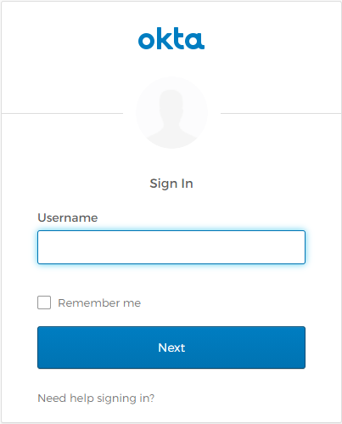
Enter your email password and click the Sign In button.
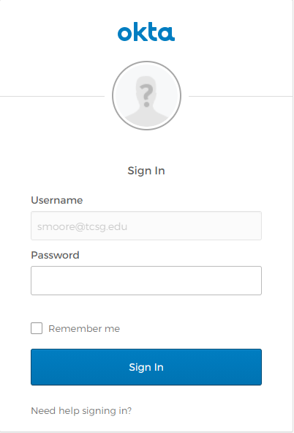

OKTA VERIFY OPTION
On the set up multifactor authentication page, select Okta Verify and click the Setup button.
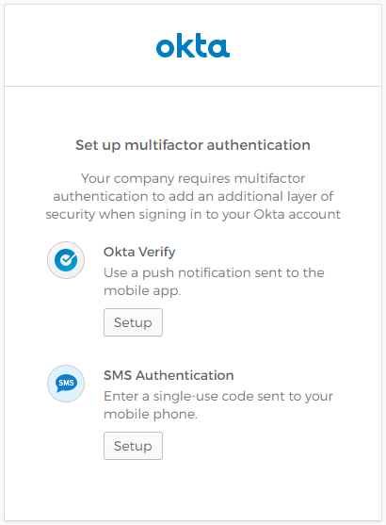
Next you will go through the installation steps for your type of phone. Choose either iPhone or Android to begin the process.
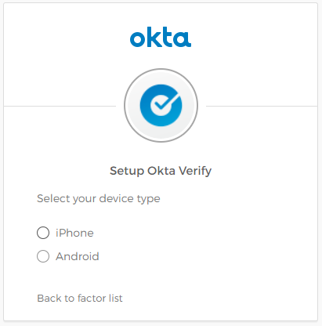
The software will be prompted to download and install the app to your phone.
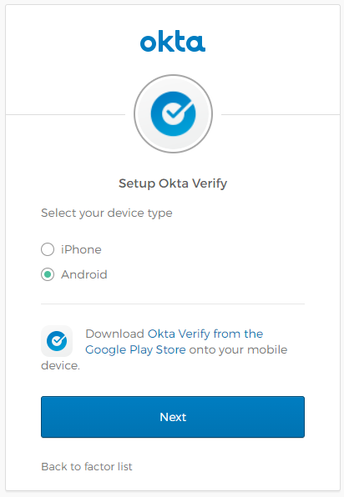

When the installation has finished, follow the steps provided to add your account.
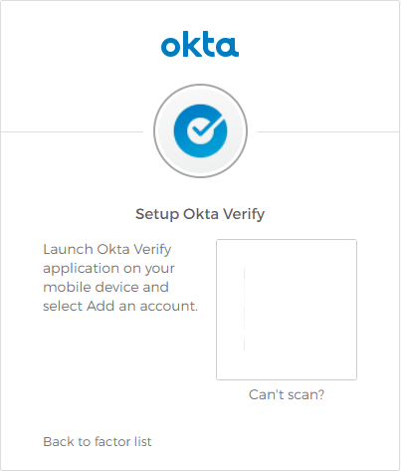
If you are unable to scan the QR code, send the activation link via SMS.
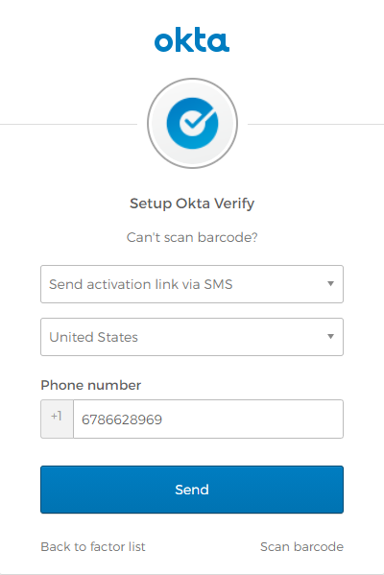
Click the Finish button to complete the installation and setup process.
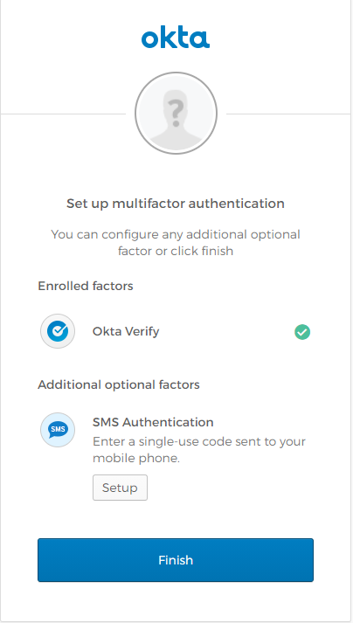

On the set up multifactor authentication page, select the bottom Setup button under SMS Authentication.
Next you will go through the installation steps for SMS Authentication. First enter your phone number, and then select the “Send code” button.
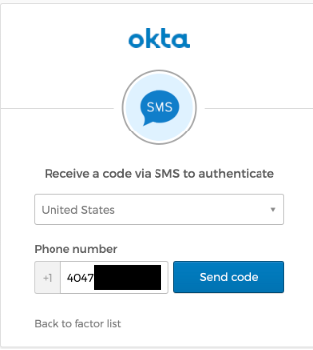
In just a few seconds you should receive a text message with a 6 digit code. Enter that code in the text box and then select the “Verify” button.
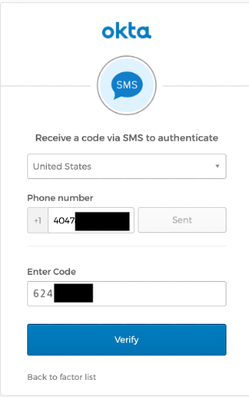
Click the Finish button to complete the installation and setup process.

When complete, you will be taken to the Okta landing page.
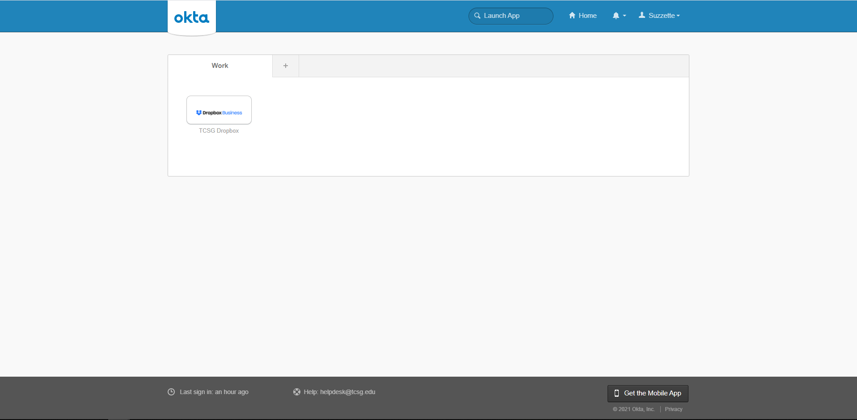

OPTIONS for Other Okta Features (NOT REQUIRED!):
Change your password: Click the settings button underneath your name at the top of the page.

Enter your password information in the form, and click Change Password.
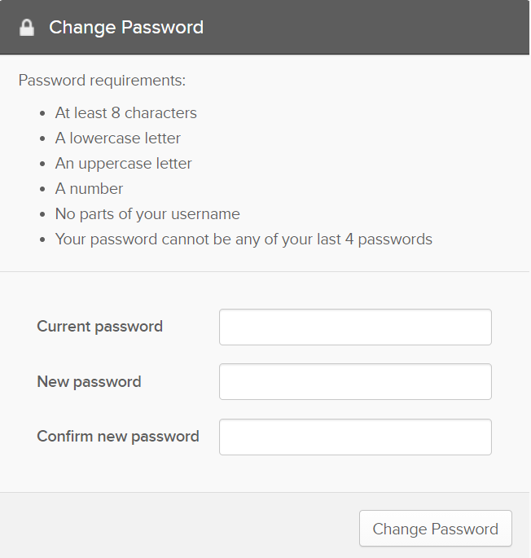
If you’ve forgotten your password, reset it by answering your forgotten password question. You can see or change your password on the settings page.
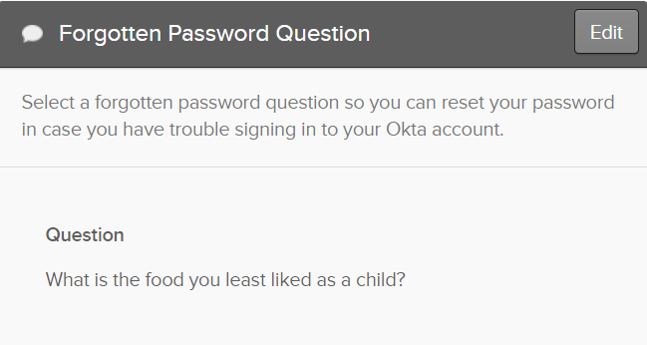

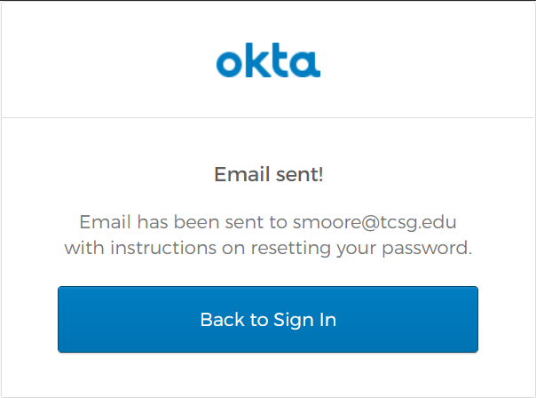

You also have the option to recover your password via text message.
