Columbus Tech Okta Single Sign On Portal

The Okta portal is used for single sign on access to all of the primary applications you will use here at CTC. To access the portal, go to:
https://columbustech.okta.com
Once at the log in page use your Columbus Tech email/username and password to log in.
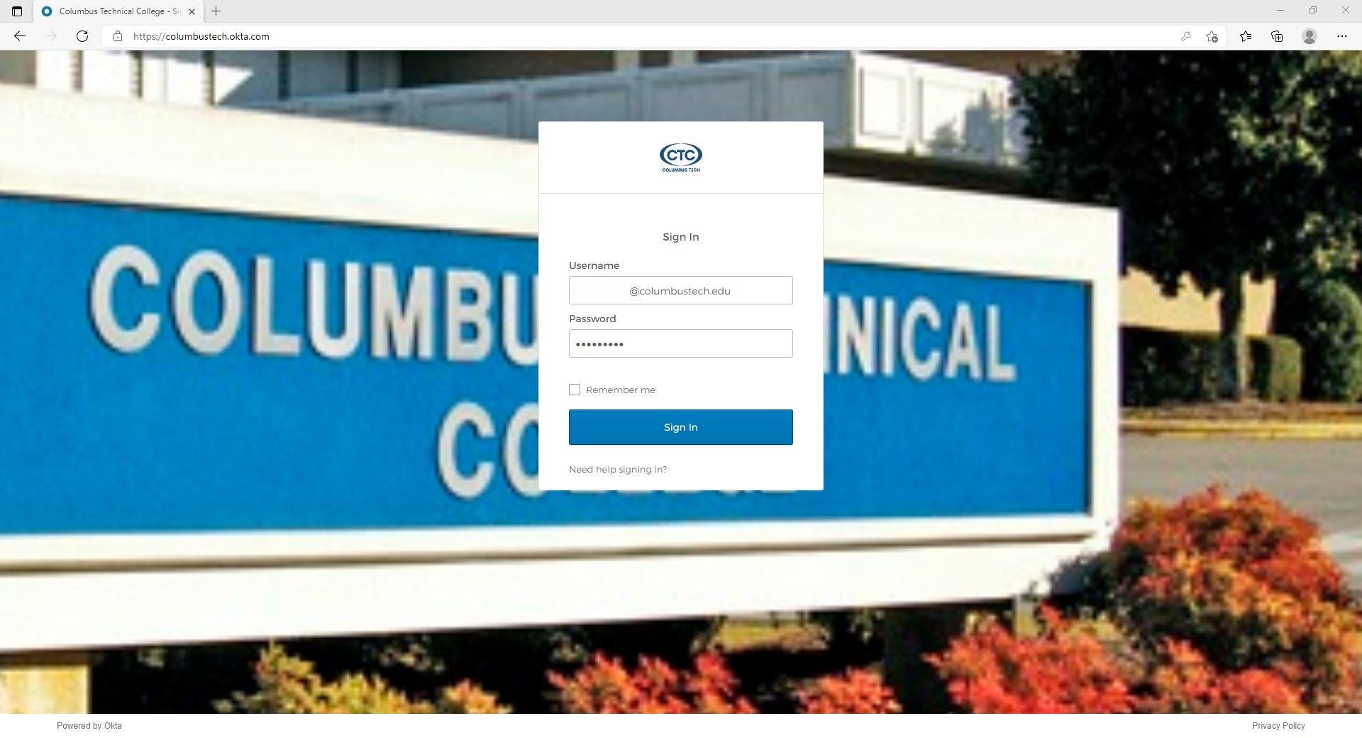
Once logged in the first time you will notice a box prompting to install a plugin. This plugin is used by some of the applications in the portal to keep them secure. Please install the plugin when prompted. Each browser will look a little different with the wording for installation.
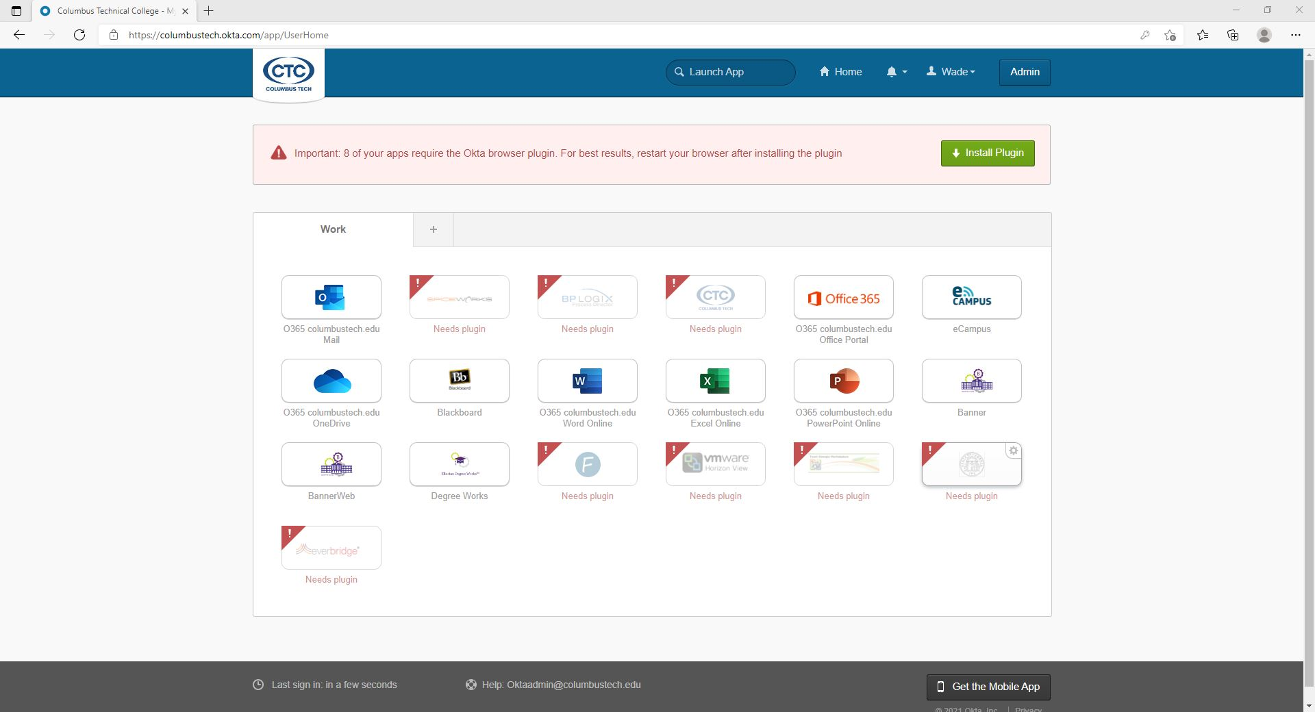
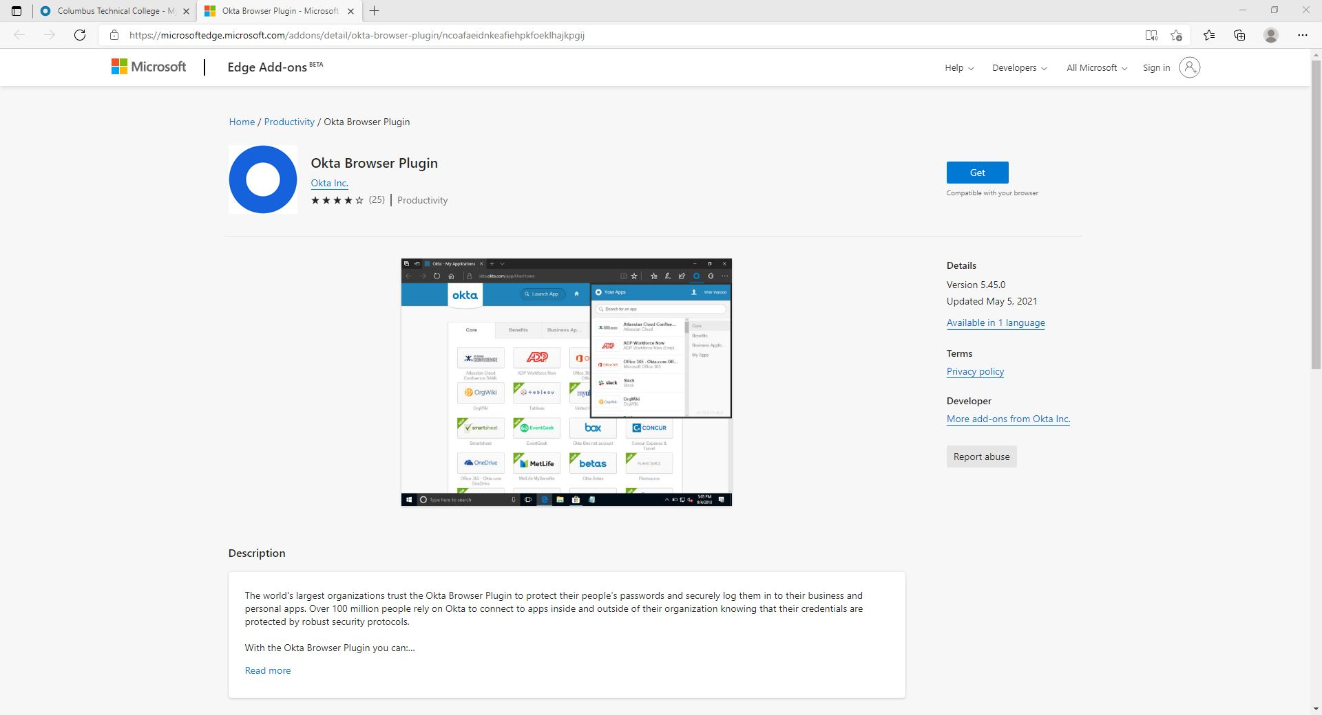
Once you have installed the plugin you can return to the Okta tab and refresh the page once you do you will see that all the applications are available to click.

This is your Okta dashboard.
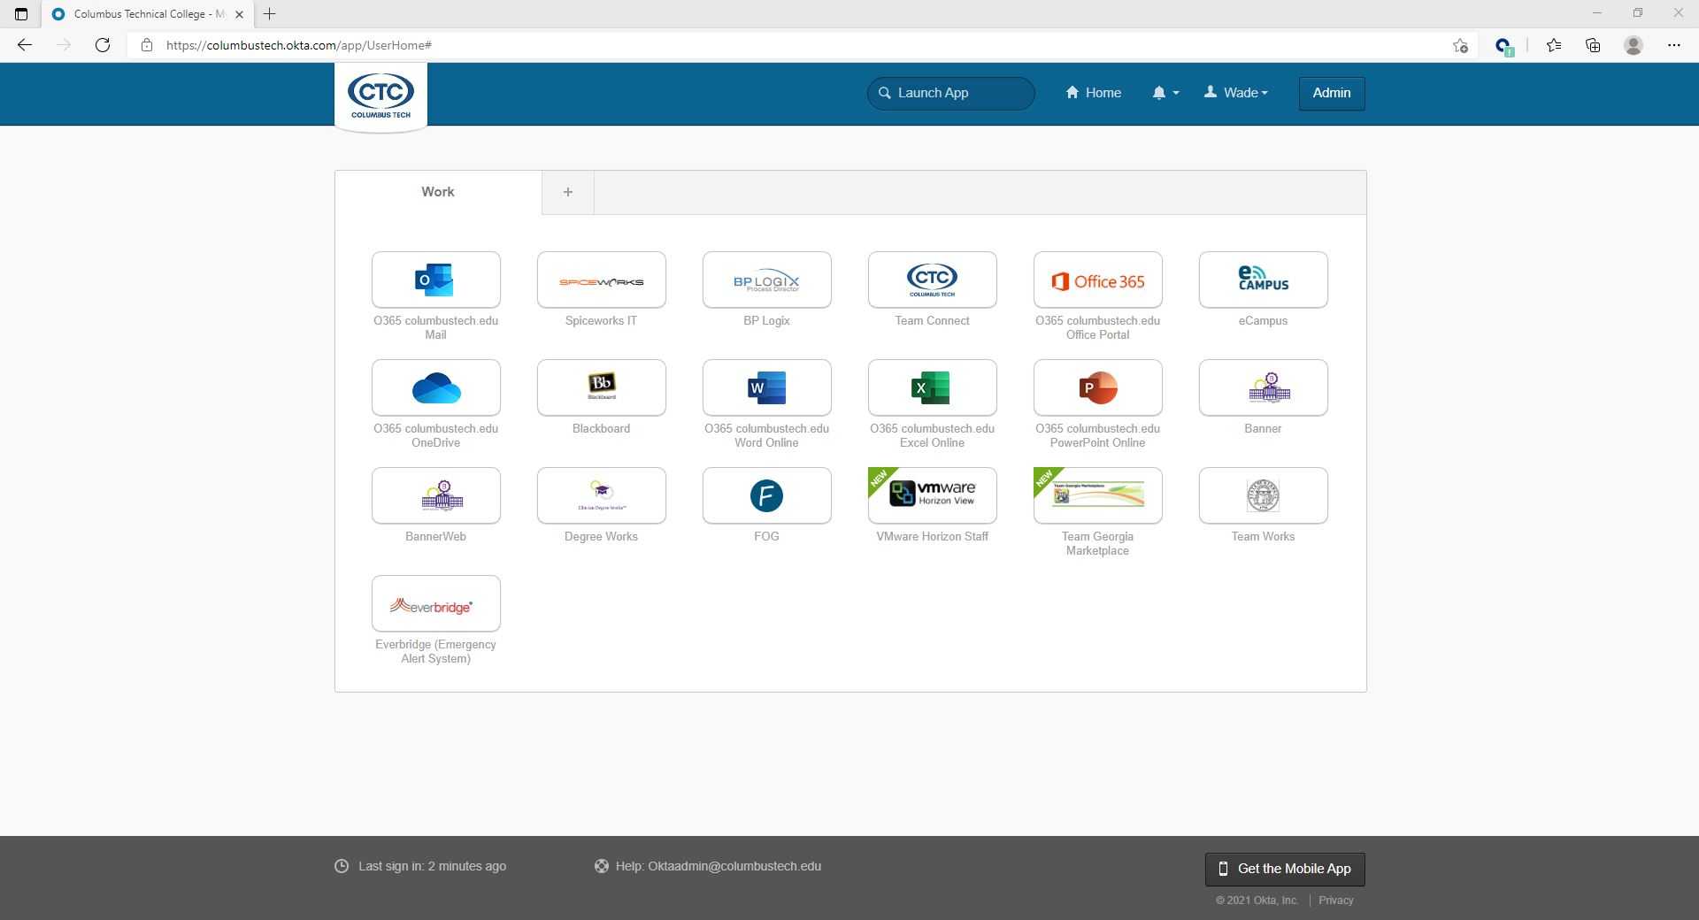
Some of the apps in the dashboard do not use your Columbus Tech credentials, so the first time you click on the app it will prompt for a username and password. Once the correct username and password is entered one time it will be saved for future log ins.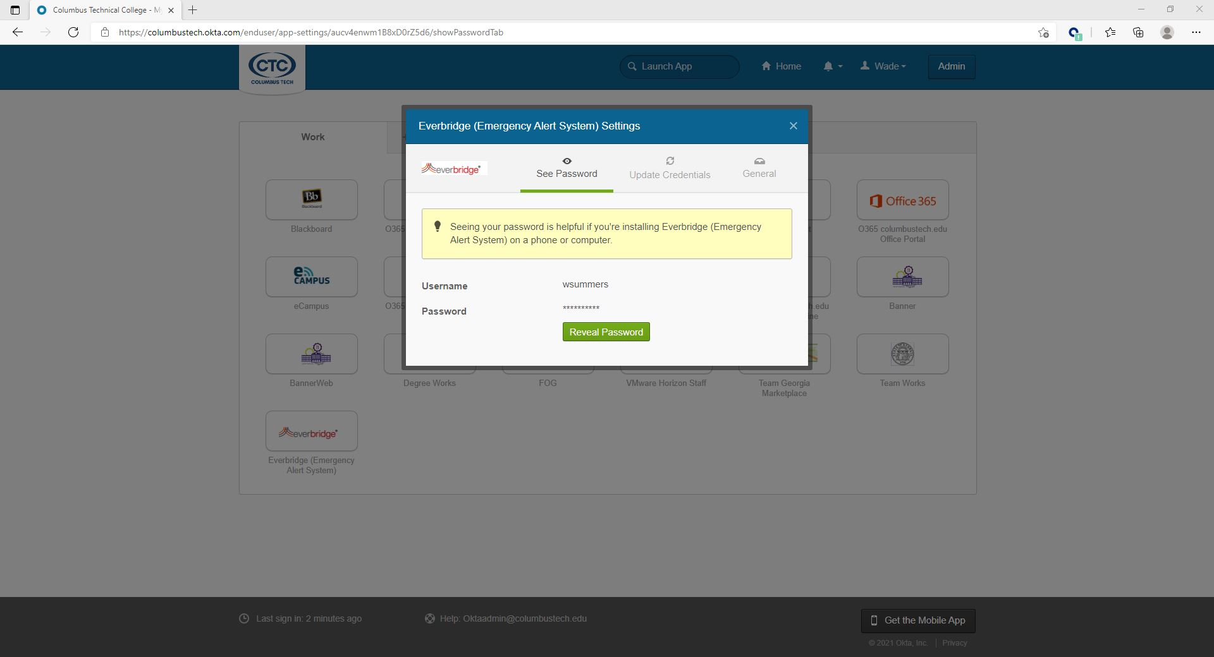
You can also adjust the application icon placement within your own dashboard to suit your likes. Just left click and hold on the icons and drag them to the desired location.
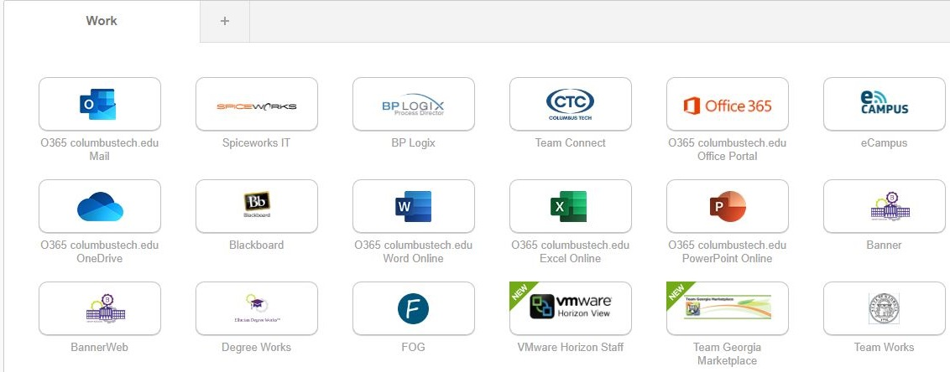
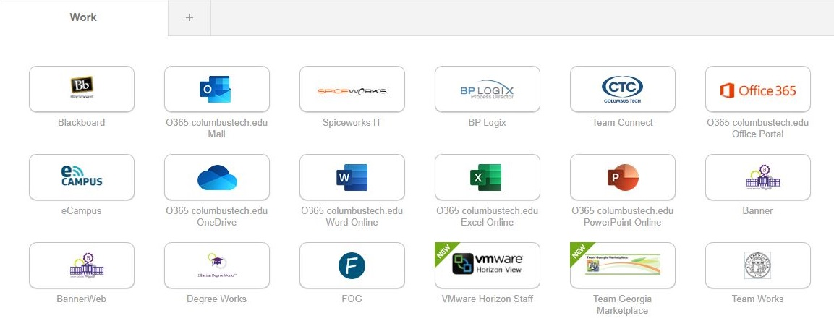

In addition, you can add a tab within your dashboard click the + symbol name the tab then you can left click and drag any applications to it that you may rarely use.
