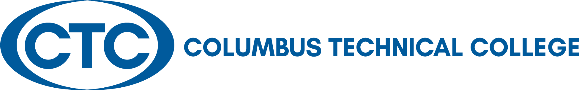

LOCAL BOARD OF DIRECTORS’ MEETING
January 24, 2023
12:30 p.m. J. Robert Jones Conference Technology Center

A G E N D A

Welcome and Call to Order Judy King

Approval of Minutes for September 27, 2022 Judy King
Approval of Minutes for December 8, 2022

Columbus Technical College Update Martha Ann Todd

Departments’ Reports via Presentation President’s Leadership Team
Academic Affairs – David Kuipers
Administrative Services – Karen Thomas
Adult Education – April Hopson
Communications – Tara Askew
Economic Development – Jamie Loyd
Institutional Advancement – Susan Sealy
Institutional Effectiveness – Amelia Mills
Operations – Tommy Wilson
Student Affairs – Tara Askew

Adjourn Judy King

Columbus Technical College
Local Board of Directors Meeting Minutes
928 Manchester Expressway
Columbus, GA 31904

Board of Directors

Laura Lee Bernstein

Chattahoochee

Travis
Chambers

Muscogee County

Senator Ed Harbison

Muscogee County

Martin Huff

M
uscogee County

Isaiah Hugley

Muscogee County

Jon
-
Erik Jones

Quitma
n C
ounty

Pam Jordan

Talbot County

Judy
K
ing

Muscogee County

David Lewis

Muscogee County

Jerald Mitc
hell

Musc
ogee County

Sen.
Randy Robertson

Harris Count
y

Crystal Shahid

Muscogee Co
u
nty

Rep. Vance Smith

Harris

County

Edwina G. Turner

Stewart County

Martha Ann Todd
President

The Local Board of Director’s Meeting was held in conjunction with the Board of Trustees’ Holiday Lunch in the Bibb Mill Event Center on Thursday, December 8, 2022.

Board Members Present: Travis Chambers, Laura Bernstein, Vance Smith, , Judy King, Isaiah Hugley, Edwina Turner, Pam Jordan, and Jon Erik Jones

Board Members Absent: David Lewis, J. Martin Huff, Randy Robertson, Ed Harbison, and Jerald Mitchell, Crystal Shahid

Staff Present: Tara Askew, Susan Sealy, Karen Thomas, Martha Ann Todd, April Hopkins, Amelia Mills, Jamie Loyd, and David Kuipers

Call to Order: Martha Ann called the meeting to order at 12:30 p.m. and afterwards, the invocation was given by Shanell Scott.

Approval of Minutes: The approval of the minutes for September 27, 2022 and December 8, 2022, will take place in the upcoming Local Board meeting which will be held on January 24, 2023.

Columbus Technical College Update –Martha Ann Todd
Presentation by Ms. Todd included the following:
- Martha Ann began by thanking everyone for their time, dedication, and continued support to CTC as it has allowed the college to reach and surpass its goals
- Registration for fall semester is up by 7%
- Clarks Kids Support
  - CTC employees along with TCSG support staff successfully provided toys for eighty-two children who were in need during the holiday season

Old Business – None

New Business – None

Adjourned: The meeting adjourned at 1:15 p.m. The next Local Board of Director’s meeting will be held on January 24, 2023.

Respectfully submitted by: Shanell Scott, President’s Office

