Okta Quick Start Guide
Use these directions for the initial setup of the Okta portal on your device(s) for security and single-sign-on use. Before proceeding you will need an okta username and password.

Student okta usernames combine the student’s lowercase initials (first, middle, and last) with the last 4 digits of their Student ID.
Student okta passwords contain the student’s lowercase initials, a dash (-), followed by their birthday (MMDDYY).

In our example the student’s username is mrk0182 and their password is mrk-061597 (student was born June 15, 1997).

Note: If your username and password do not work or you do not have a middle name, omit the middle initial from username and password.

1) Go to https://columbustech.okta.com. Enter your okta username and click Next. | 2) Enter your okta password and click Verify.
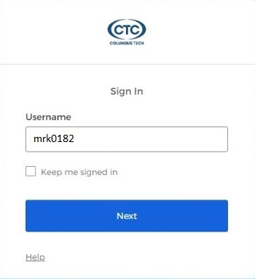 | 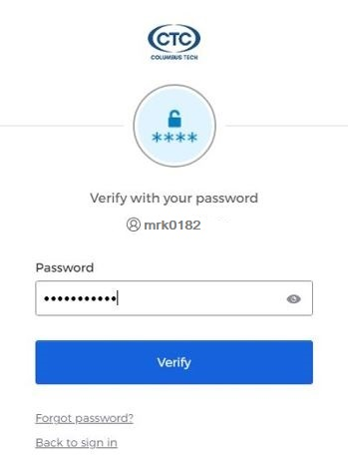

3) Click Set up and proceed to next screen. | 4) Choose or create a security question, enter answer, and click Verify.
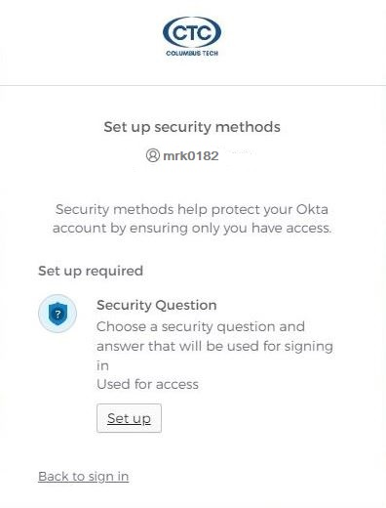 | 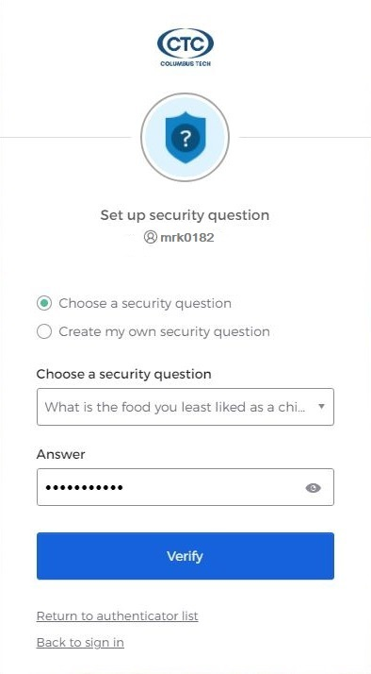

5) Choose a security method (required). We will choose the Phone Set up option. | 6) We will choose the SMS (text) option. Enter a phone number and click Receive a code via SMS.
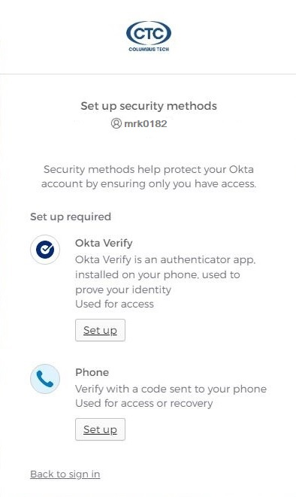 | 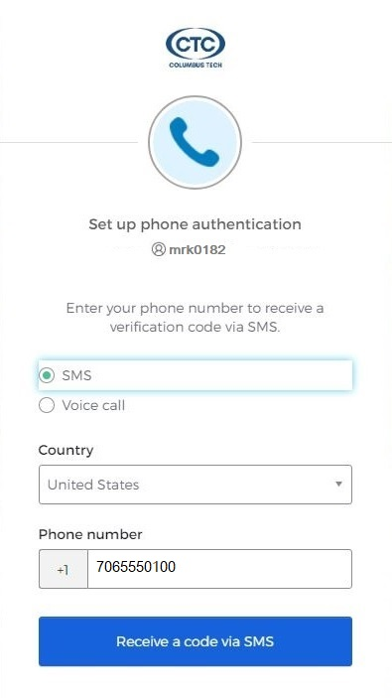

7) This step is optional. If you do not want to add another security method, click Set up later. We will choose the Okta Verify option. | 8) Click Set up to proceed to the next screen. Note: You will need two devices to set up Okta Verify, typically a PC or Mac and a smart phone.
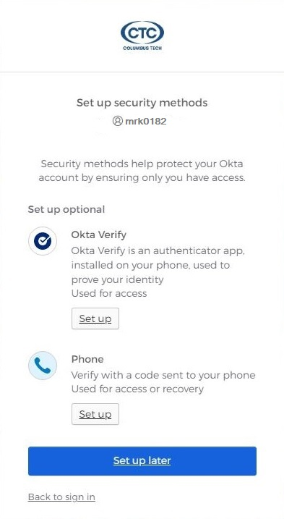 | 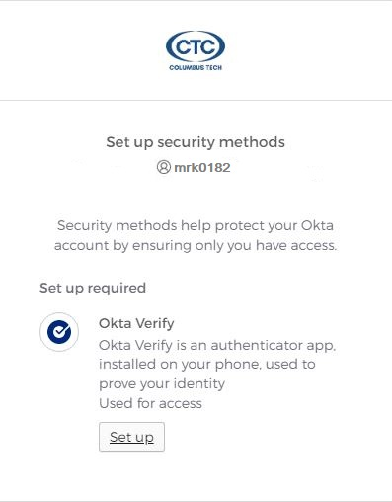

9) Download the Okta Verify app from the App Store (iPhone or iPad) or Google Play (Android devices) and open the app. Note: If asked for an Organizational URL enter columbustech.okta.com. When prompted, tap Scan a QR code and then scan the QR code.
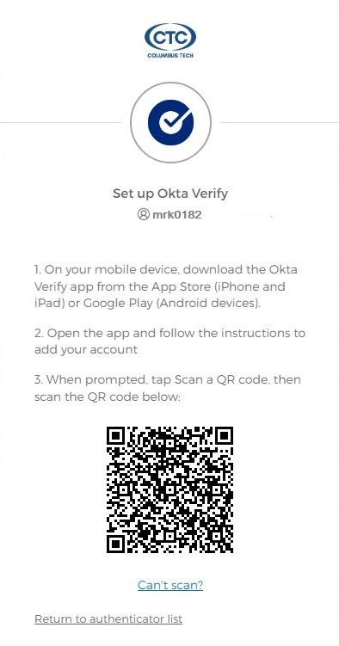

10) Once you set up your security method(s) you will have access to your apps. Note: You can click and drag apps to a location of your choosing.
