|  |
| --- |
| cid:image001.png@01D5D5D3.40E801A0  ***Local Board of Directors Meeting***  ***In Conjunction with the CTC Graduation Ceremony***  ***January 23, 2020 at 6:30 p.m.***  ***Columbus Civic Center***  ***A G E N D A***  ***Welcome and Call to Order Edwina Turner***  ***Approval of the Minutes for December 12, 2019 Edwina Turner***  ***Meeting Adjourned***  ***Reports are postponed until the next meeting.***  ***Board members proceeded to attend the Graduation Ceremony.*** |

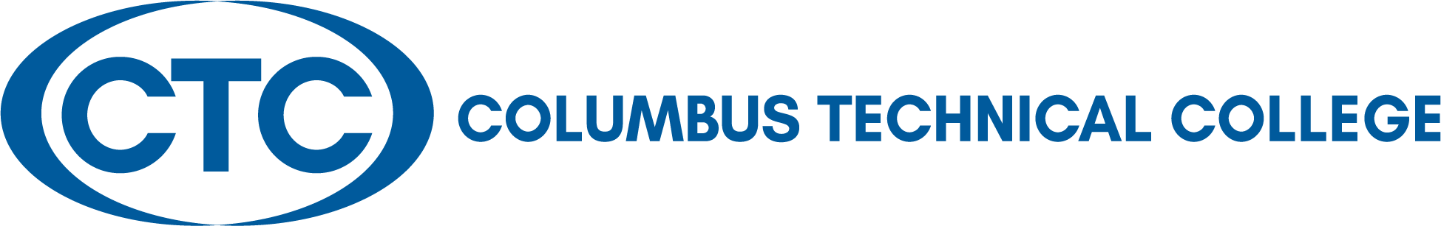

**Board of Directors:**

**Travis Chambers**

Muscogee County

**David E. Fox**

Muscogee County

**Victoria Harris**

Quitman County

**Judy King**

Muscogee County

**Kenneth Parker**

Talbot County

**James “Jim” Trott**

Harris County

**Edwina G. Turner**

Stewart County

**Martha Ann Todd**

President

***Local Board of Directors’ Meeting Minutes***

***Robert L. Wright Health Science Center***

***Thursday, December 12, 2019 at 12:00 p.m.***

The Local Board of Director’s Meeting was held in conjunction with the Board of Trustees’ Holiday Lunch in the Robert L. Wright Health Science Center at Columbus Technical College on Thursday, December 12, 2019.

***Local Board Members Present:*** Travis Chambers, David Fox, Judy King, Kenneth Parker, Jim Trott, and Edwina Turner

***Local Board Member Absent:*** Victoria Harris

***Guests:*** April Hopson, Takara Thomas, Kevin Caldwell, Ken Lockhart, Tara Askew, and Jesus Xavier Gonzalez

Martha Ann Todd welcomed everyone for attending the meeting and gave the invocation.

***Approval of Minutes***: The first order of business was to approve the October 28, 2019 Local Board Meeting Minutes. Chairman Edwina Turner called for any corrections to the minutes as written. After hearing none, she asked for a motion to approve the minutes. Motion was made by Mr. Jim Trott and seconded by Mr. David Fox. The minutes were unanimously approved.

EAGLE student, Takara Thomas, and GOAL student, Jesus Xavier Gonzalez, both shared their story and how CTC have impacted their life as a student at CTC.

***Adjourned*:** The meeting adjourned at 1:15 p.m. The next Local Board of Director’s meeting will be held in conjunction with the CTC Graduation on January 23, 2020 at the Columbus Civic Center at 7:00 p.m.

Respectfully submitted by: Mary Alexander, President’s Office