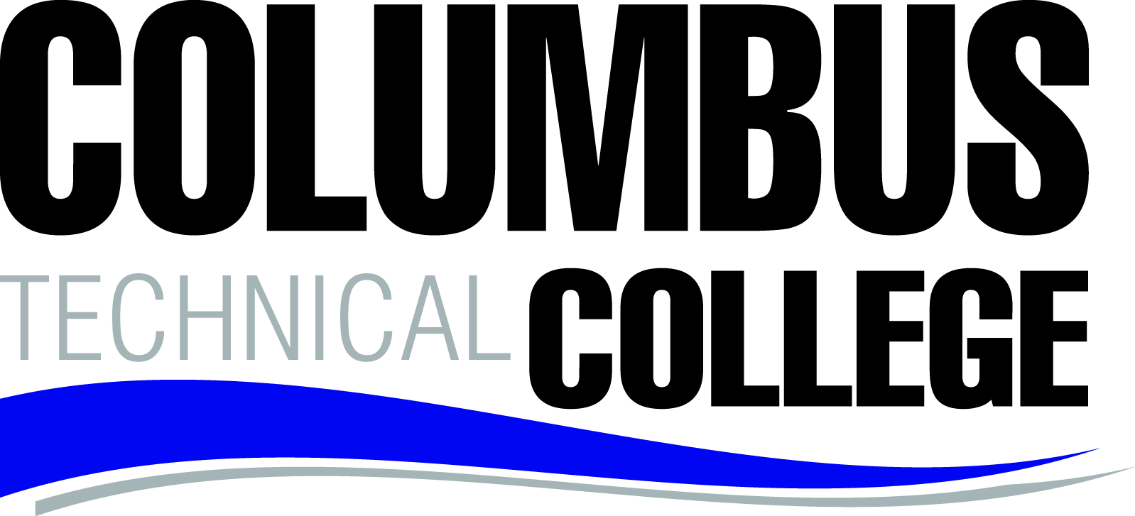

LOCAL BOARD OF DIRECTORS MEETING
September 26, 2016
12:30 p.m. J. Robert Jones Conference Technology Center

A G E N D A

Welcome and Call to Order David Fox

Approval of Minutes David Fox

STAFF REPORTS

President’s Report Lorette Hoover

Adult Education April Hopson

Community & College Relations Cheryl Myers

Institutional Advancement David Fletcher

Economic Development Jamie Loyd

Operations Tommy Wilson

Administrative Services Karen Thomas

Student Affairs Tara Askew

Academic Affairs Melanie Thornton

Institutional Effectiveness Monique Baucham

Adjourn David Fox

Local Board of Directors Meeting Minutes
928 Manchester Expressway
Columbus, GA 31904

Monday, August 22, 2016
12:30 p.m. J. Robert Jones Conference Technology Center

Board Members Present: Velma Bright, David Fox, Joe Slade Johnson, David McCurry, Ben Richardson, Jim Trott and Edwina Turner

Staff Present: Tara Askew, Monique Baucham, David Fletcher, Lorette Hoover, April Hopson, Gloria Johnson, Jamie Loyd, Cheryl Myers, Karen Thomas, Melanie Thornton, and Tommy Wilson

Call to Order: Chairman David Fox called the meeting to order at 12:30 p.m.

Approval of Minutes of Last Meeting: Chairman Fox called for any corrections to the minutes as written. After hearing none, he asked for a motion to approve the Minutes for July 25, 2016. Upon appropriate motion and second, the minutes were approved.

Staff Reports

President’s Report
Lorette Hoover’s Report:
Ms. Hoover asked April Hopson to make a presentation about Adult Education.

Adult Education Report
April Hopson’s report:
- Ms. Hopson discussed the percentage of populations served by Columbus Technical College in the six counties combined (Chattahoochee, Harris, Muscogee, Quitman, Stewart, and Talbot) for the past three years:
- FY 2014 (5.9%); FY 2015 (5.7%); FY 2016 (4.6%)
Ms. Hopson also discussed GED Graduates by county of Residence for FY2016:
- Chattahoochee (13); Harris (18); Muscogee (183); Quitman (1); Stewart (8); Talbot (1)

Community & College Relations
Cheryl Myers’ report:
- Ms. Myers presented a video on the Active Shooter Drill and the Radiologic Technology Pinning Ceremony.
Social Media
- Facebook’s Likes have increased from 8, 859 in July to 9,160 as of August 17.
- Twitter followers have increased from 512 in July to 520 as of August 17.

Institutional Advancement
David Fletcher’s report:
Advancement Office
- We (Brandie and I) attended the following events:
- Raisers Edge training on July 26-27 in Macon. The training was designed for non-profits to improve their efficiency, build strong relationships with donors, and help raise more money to support our mission.
- QEP Kick-Off at Columbus State University the week of August 8th.
- Robert L. Wright Symposium on August 18, 2016.

Columbus Technical College
Local Board of Director’s Meeting Minutes
Monday, August 22, 2016
Page 2

Scholarships
- Since June 1, 2016, a total amount of $5,937 has been awarded in scholarships for students’ assistance with certification testing, transportation, and books.
Foundation
- Mr. Fletcher stated that he met with the Foundation Executive Committee for the first time on August 9th. He will meet with the full Foundation Board on Thursday, August 25.
- Paperwork will be submitted by September 2 for the Foundation Board of Trustees to achieve the status of a “Role Model Board”.
- Mr. Fletcher invited everyone to attend the retirement reception to be held on Thursday, August 25 at 1:00 p.m. in honor of Ms. Gloria Dodds. He also recognized Ms. Dodds for her dedication to the Foundation and her support in raising over $10 million for the Columbus Technical College Foundation, Inc.

Economic Development
Jamie Loyd’s report:
Customized Training
- Customized training and continuing education programs are on-going.
- Currently there are 79 twelfth graders enrolled in Dual Enrollment classes and a total of 246 ninth graders enrolled in Career Connect classes.
- As of July 2016, a total of 33 more drivers’ education students have been certified. Our goal is to have 150 more certified before December 31st.
- The on-line training and assessment program for the Department of Drivers’ Services and Department of Juvenile Justice have been completed.

Operations
Tommy Wilson’s report:
- Designs have been submitted to Norfolk Southern Rail Road for the proposed crossing from the North campus to the Wright building and are awaiting approval. Construction will begin in 90 days upon approval.
- The Albion Scaccia firm, general contractor and Clark Patterson Lee, Architecture Engineer, was confirmed by the committee as the awarded contractors for the world class welding lab project. Work is scheduled to begin on October 7.
- Computers and banner programs continue to be updated as on-going projects.

Administrative Services
Karen Thomas’ report:
- Ms. Thomas gave the financial report for the period ending July 31, 2016.
- The Technical College System of Georgia (TCSG) reported that there will be a delay in implementing the new CONCUR travel system. However, Columbus Technical College is still on scheduled to go live on the system this Fiscal Year 2016.

Student Affairs
Tara Askew’s report:
Enrollment
- Total applications received for fall semester is 2,201.
- Total students registered for fall semester is 3,302.
- Student Leadership Team will travel to Gwinnett Technical College to tour their new One-Stop Enrollment Center on September 12, 2016.
- Pinning Ceremonies was held for CNA Surgical Technology and Radiologic Technology on July 28.
- Medical Coding Pinning Ceremony was held at the Martin Army Hospital on August 1.

Columbus Technical College
Local Board of Director’s Meeting Minutes
Monday, August 22, 2016
Page 3

Campus Life and Recruitment
The Student Leadership Council attended the Bob Wright Symposium on August 18.
Financial Aid Services
- A total of 55 students and 25 faculty and staff mentors participated in the Mentor program during the summer semester.

Academic Affairs
Melanie Thornton’s report:
Division of Academic Support
- The SEMN 1000 class is at a maximum capacity of 600 students.
- The support lab coordinators are working with instructors to target the following classes:
  - Anatomy and Physiology
  - Introduction to Computers
  - Learning Support
  - Gateway English and Math
High School Initiatives
- New participants for MOWR enrollment include: Hallie Turner, Lassiter Private School, Georgia Cyber Academy, Calvary Christian, and Marion County.
- The Culinary Arts program will be offered in the spring at Jordan High School. Teachers are in process of being credentialed to teach in the high schools.

Institutional Effectiveness
Monique Baucham’s report:
Institutional Effectiveness
- Summer course evaluations closed at 43.6% (tripled from last year).
- Status of Strategic Plan – 2nd Year: There were 33 objectives in the strategic plan. During an audit of all of those, there were only four that were not specifically addressed in the assessment plan for FY 2016.
- Following the President Leadership Team (PLT) Retreat in June, Tommy Wilson will make sure we stay on task with achievements which are geared toward the strategic plans.
Performance Accountability System (PAR/Perkins)
- We will work with Academic Affairs and Administrative Services to facilitate a mock PAR visit this academic year.
Complete College Georgia/Perkins Initiatives will include these programs:
- Increase Success in Remedial Courses
- Increase Graduation Rate
- Degree Production
Retention increased from 57.9% to 61.7% at the end of AY 2016.
Graduation rate increased from 54.5 to 56.2 at the end of AY 2016.

Old Business: None

New Business: None

Adjourn: There being no other business for discussion, the Board adjourned at 1:35 p.m. The next Board meeting is scheduled for September 26, 2016.

Minutes respectfully submitted by: Mary Alexander, President’s Office

