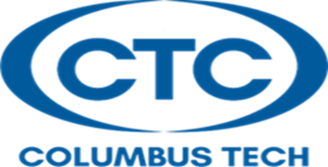

Aims and Objectives:
The Funeral Service Education Program at Columbus Technical College has as its central aim the recognition of funeral service personnel as members of a human services profession; members of the community in which they serve; participants in the relationship between bereaved families and those engaged in the funeral service profession; professionals knowledgeable of and compliant with federal, state, provincial/territorial, and local regulatory guidelines in the geographic area where they practice, as well as professionals sensitive to the responsibility for public health, safety, and welfare in caring for human remains.
The Funeral Service Education program also has the following objectives:
• To enlarge the background and knowledge of students about the funeral service profession.
• To educate students in every phase of funeral service and to help enable them to develop proficiency and skills necessary for the profession.
• To educate students concerning the responsibilities of the funeral service profession to the community at large.
• To emphasize high standards of ethical conduct.
• To provide a curriculum at the postsecondary level of instruction.
• To encourage student and faculty research in the field of funeral service.

The Funeral Service Education Program is not accredited by the American Board of Funeral Service Education. Students graduating from this program are not eligible to take the National Board Examination or any state board examination for which graduation from an ABFSE accredited program is required.

