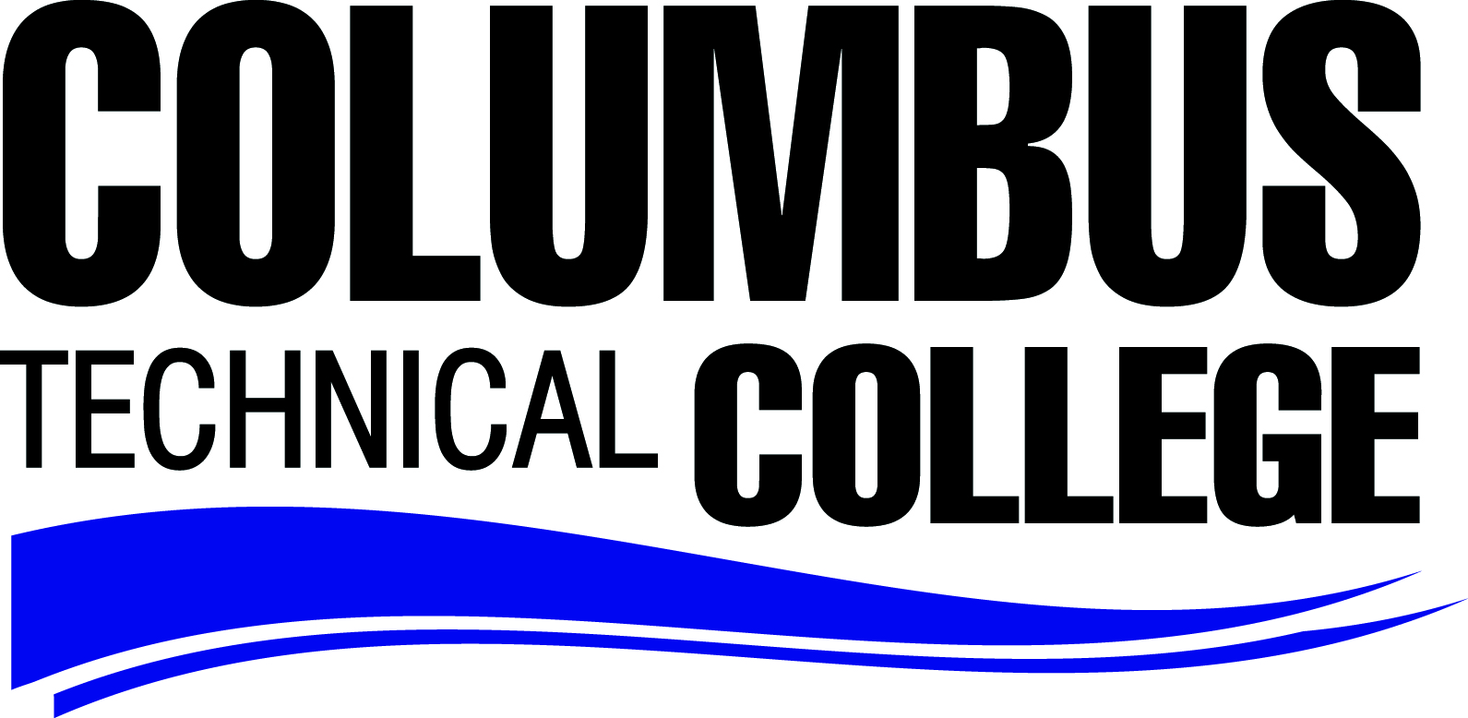

Application Process for the Associate Degree Nursing Program and the
LPN to Associate Degree Nursing Program
To apply to the Associate Degree Nursing Program & LPN to Associate Degree Nursing program you must meet the Admission procedures as outlined by the College. This includes to apply To Columbus Technical College first. Have all transcripts sent to the Admissions department for credit transfer.
The Associate Degree Nursing Program receives applications every year from September 15 through October 1st. Applications must be turned in by October 1st no later than 5:00 pm to be considered for competitive ranking.
FIVE (5) PREREQUISITES USED FOR GPA RANKING MUST BE COMPLETED BY THE END OF FALL SEMESTER:
ENGL 1101 - Composition and Rhetoric
MATH 1111 – College Algebra
****BIOL 2113 & Lab – Anatomy and Physiology I
****BIOL 2114 & Lab - Anatomy and Physiology II
****BIOL 2117 & Lab – Microbiology
****BIOLOGY COURSES CANNOT BE OLDER THAN SEVEN (7) YEARS.

Three (3) Prerequisites NOT USED FOR RANKING.
PSYC 1101 – Introduction to Psychology
HUMN 1101 – Introduction to Humanities (Art Appreciation or Music Appreciation will substitute for HUMN)
SPCH 1101 – Public Speaking
Overall GPA of Eight (8) Prerequisites must be a minimum of 2.5.
**Other requirements for competitive ranking:
Accuplacer: All applicants must take Accuplacer testing for competitive ranking.
Reading Comprehensive 64
Sentence Skills 70

Pre-NLN Exam is required for Competitive ranking.
To be eligible for competitive ranking the applicant must score a minimum of 75% (percentile) Score 121 on the Pre-NLN Exam.
The Pre-NLN exam can be taken ONCE a semester.
Study Guide recommended by students is the NLN/RN Pre-Entrance Exam
Review Guide – 3rd Editions. Students can search Amazon.com for study guides also.
To schedule the Pre-NLN exam call the CTC Library at 706-649-1822. The test will be given in Room L-606 in the CTC Library. Cost $75.00
Packet Deadline – October 1st of each year
Begin taking applications September 15th
Packet consists of:
You must complete two forms:
- Letter of Intent Form (on website directions below)
- Personal Data Form (on website directions below)
- Include a copy of your NLN Exam scores
- If you are a LPN please turn in a verification of your license.

Both forms are found on the Columbustech.edu website by selecting Academic tab on the yellow tab bar. Then select Program of Study. Then select from the left column under program of study Division of Health Science and Nursing. Select from under the picture the FORMS link. The two stated above forms will be found on this page. The forms are also located in the Administrative Offices at The Wright Building located on the third floor.

