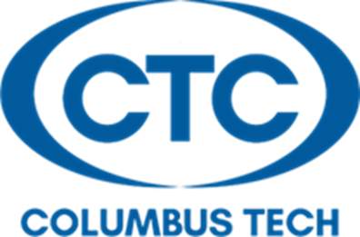
Applications for the following programs can be submitted in the
Wright Building on the 3rd floor (WH 3323). Competitive Packet Turn-In Times are
Monday-Thursday between 9:00am-11:30am & 12:30pm-5:00pm
before the application deadline dates. Interested students can get the forms required for the application process via the following link: https://www.columbustech.edu/academics/forms.cms
If you require further assistance, please contact Tamika L. Williams at 706-225-0502 or by email at tlwilliams@columbustech.edu
*Students transferring in grades from another college must have their grades submitted to the Admissions Office via official transcript by the end of fall semester (October applications) and by the end of spring semester (March applications) *
Program | Application Deadline Date | Application Packet Requirements | Program Director
Associate Degree Nursing | October 1st  5:00pm | Letter of Intent  Pre NLN Scores | Lori Striblin  lstriblin@columbustech.edu  706-225-0541
Radiologic Technology | October 1st  5:00pm | Letter of Intent | Kimberly Whitaker  kwhitaker@columbustech.edu  706-225-0514
Respiratory Care | October 1st  5:00pm | Letter of Intent | Mark Thorne  mthorne@columbustech.edu  706-225-0506
Diagnostic Medical Sonography | October 1st  5:00pm | Letter of Intent | Regina Ridgley  rridgley@columbustech.edu  706-641-4012

Program | Application Deadline Date | Application Packet Requirements | Program Director
Dental Assisting | March 1st  5:00pm | Letter of Intent | Sharron Cook  scook@columbustech.edu  706-225-0532
Dental Hygiene | March 1st  5:00pm | Letter of Intent | Casey Morris  cmorris@columbustech.edu  706-225-0533
Surgical Technology | March 1st  5:00pm | Letter of Intent | Carl Sandy  csandy@columbustech.edu  706-225-0518
Practical Nursing | March 1st  5:00pm | Letter of Intent  TEAS Exam Scores | Lori Striblin  lstriblin@columbustech.edu  706-225-0541

Updated 9/18/2019

