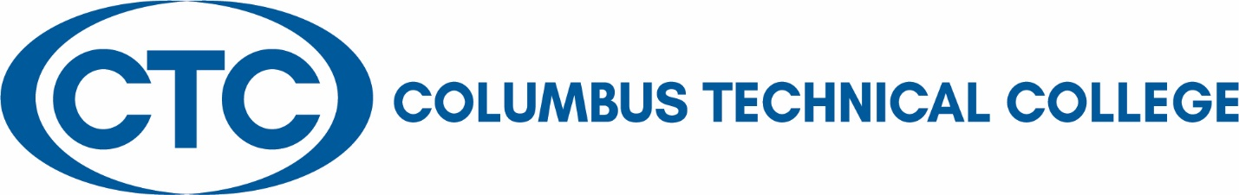

Programs offer effective occupation-based instructional delivery where appropriate:
Occupation-based instructional delivery systems include labs, practicum, internships, and clinicals.
Occupation-based instruction is defined in the following manner:
- Lab: any learning activity that is not specifically designated as lecture. Activities can include, but are not limited to;
- Demonstration: teacher assisted learning activities, normally requiring some out-of-class preparation by the student, and may require out-of-class practice assignments;
- Practicum: instruction which emphasizes structured activities requiring application and practice of occupational competencies. Normally requires only limited out-of-class preparation by the student and no out-of-class practice assignments; and
- Internship or Clinical: instruction which emphasizes supervised work-experience activities requiring the application of occupational competencies. Normally requires only limited out-of-class preparation by the student and no out-of-class practice assignments. Clinical is normally associated with health technology related programs.
Degree, diploma, and technical certificate of credit programs that require occupation-based instruction, do so on the basis of designated essential competency areas and courses for the given program.

Distance Education Courses:

O = Online These courses are taught using the Internet with the bulk of the course content, activities and interactions occurring online. Online courses may require an on-site component and that component must be detailed in the course catalog. Online courses may require proctored exams.

V = Web-enhanced These courses are traditional classroom courses that use
the Internet as an important component of the course. The web-based component of the course supports classroom instruction and may require students to use the Internet in order to interact with one another and the instructor, to review content, do research, complete and/or submit assignments, or take tests. Typical web-enhanced courses will include several of the following elements online: Syllabus, Calendar, Readings, Resources, Bibliography, Glossary, Links to Professional Organizations, Current News, Lecture Notes, Listserv, Discussion Board, Tests.

K1, K2 = Hybrid These classes are taught partially via the Internet and partially via the classroom. Hybrid courses differ from web-enhanced courses in that web-enhanced courses are assigned to a classroom for every contact hour described in the course catalog.

K1 = Hybrid These courses include 50 percent or greater instruction via distance learning.

K2 = Hybrid These courses include less than 50 percent instruction via distance learning.

X = Interactive Audio/Video These courses are primarily taught using one or more interactive audio/video technologies. Those technologies may include but are not limited to GSAMS or other two-way interactive audio/video, including Internet-based interactive audio/video.

Z = Non-Interactive Audio/Video These courses are primarily taught using one or more non-interactive audio/video technologies. Those technologies may include but are not limited to videocassettes, satellite, and/or cable television.

