Library Proctoring Procedures
If you need to take a proctored exam for one of your classes, but have an unavoidable schedule conflict which will prevent you from attending the proctored event scheduled by your instructor for the entire class, you may elect to schedule a proctoring session in the CTC Library. To do so, be sure to first communicate with your instructor concerning your schedule conflict, and discuss your alternative proctoring options. If your instructor approves for you to be proctored in the Library, follow the instructions below to make the arrangements.
- Log into Blackboard.
- Look below your Course List to find the My Organizations list
- Locate the link to the Virtual Library Services organization. If you don’t already have a link, you will need to self-enroll using the Student Organizations Self Enroll Catalog link below the My Organizations list. If you need assistance getting enrolled into the Virtual Library Services organization, please contact the CLICK Lab.
- Select the link to go to Virtual Library Services organization.
- You will be taken to the Virtual Library Services Home page (example screen capture below).
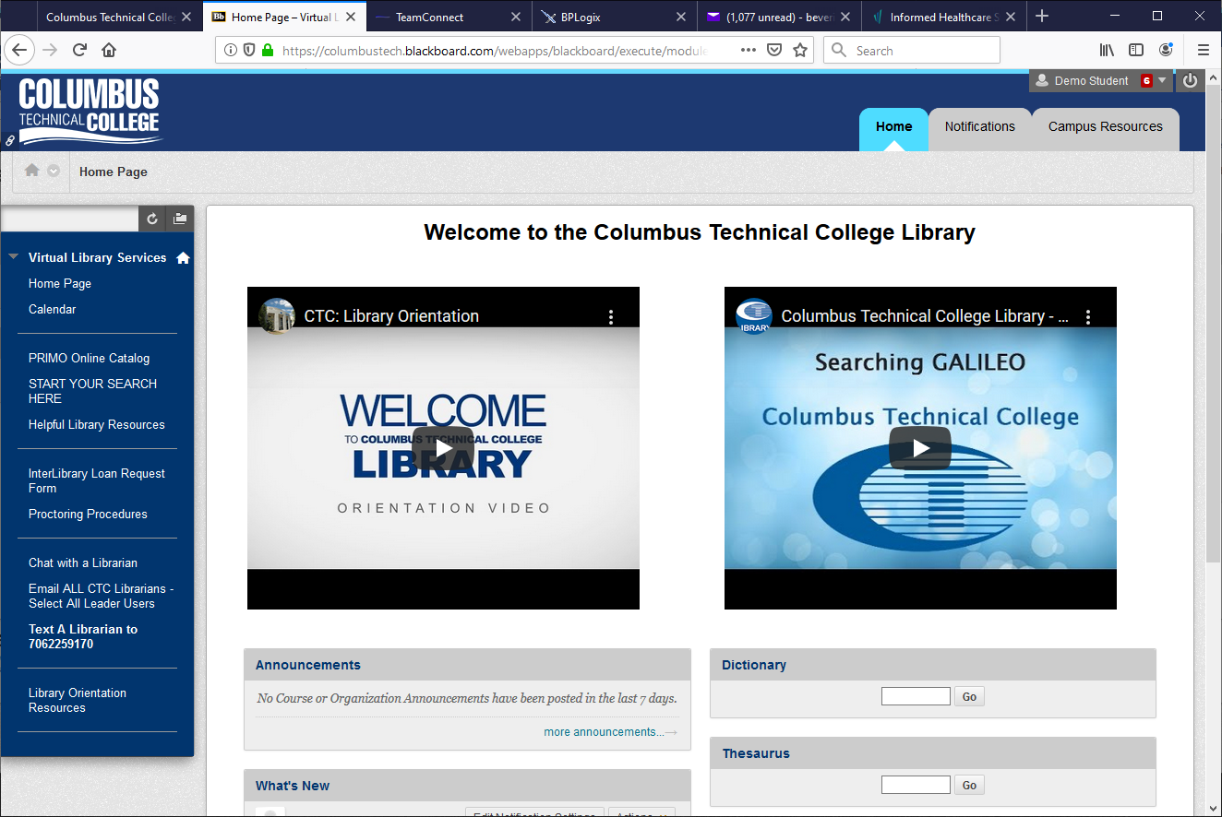
- In the organization menu on the left side of the page, select the Proctoring Procedures link.

- You will be taken to the Proctoring Information page (example screen capture below).
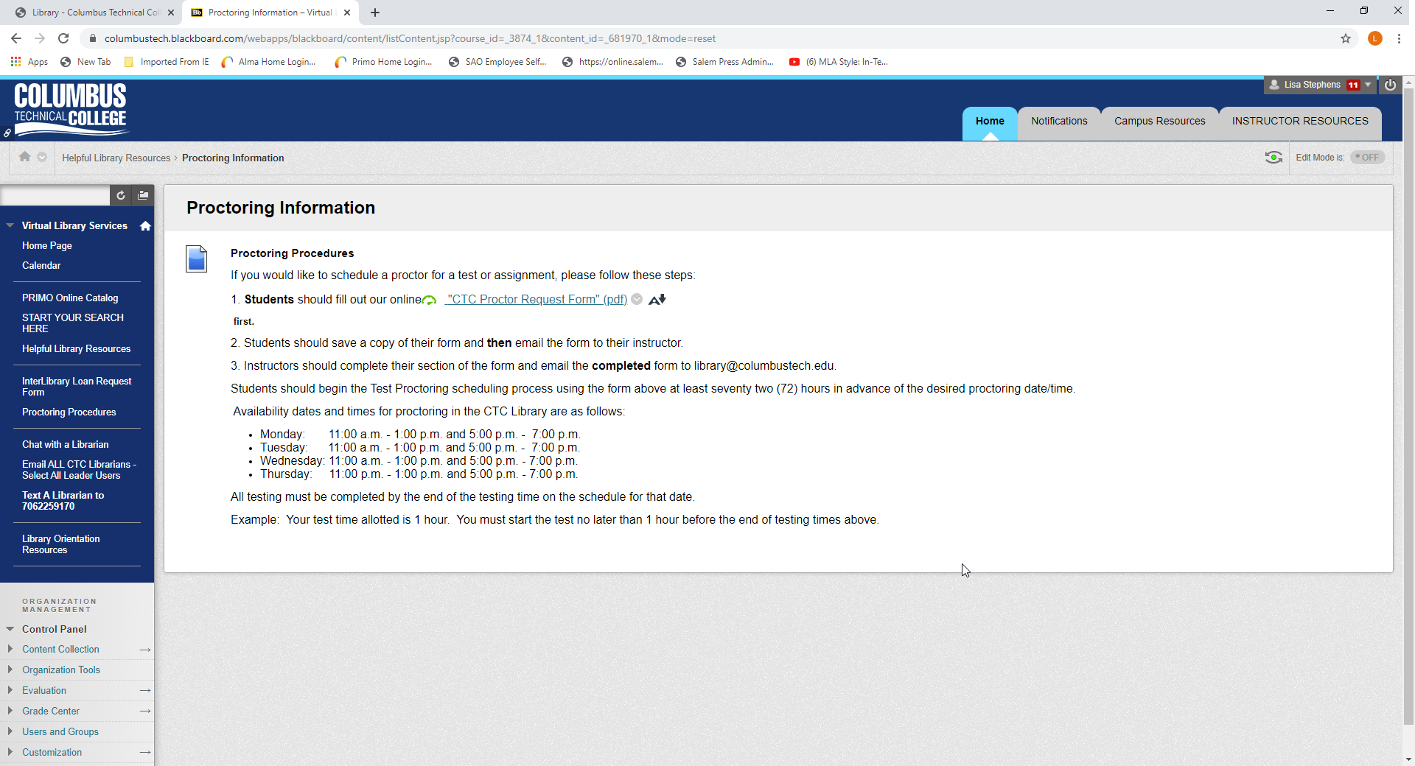

- Please read the provided Proctoring Procedures.
- Select the provided link to open the CTC Proctor Request Form. On the form are instructions for the student and for the instructor.
- Complete the form, being sure to include all the required information, such as your desired date and time to be tested.
- Save the completed form.
- Send the form to your instructor via your CTC Student Email.
- Your Instructor will send the approved form to the Library, including instructions for the exam.

Information about Proctoring for Students
- The proctoring that is done in the library is done by appointment for individual students. Whole classes will need to be proctored by instructors.
- We require at least 72 business hours of advanced notice of the desired date/time.
- Before sending your request form to your instructor please check to make sure you listed a time that we are available. We proctor from 11:00 am to 1:00 pm and 5:00 pm to 7:00 pm.
- After the library receives the form from your instructor, we will send you an email confirming your appointment and will copy your instructor in the email. If you need to cancel or re-schedule your appointment, please call the Library at 706-649-1852.

