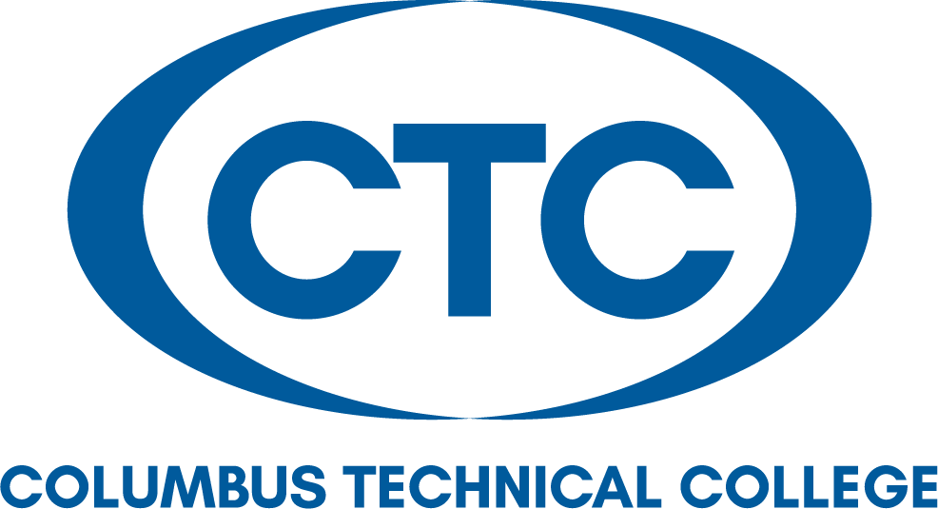

Board of Directors:

Travis Chambers
Muscogee County

David E. Fox
Muscogee County

Victoria Harris
Quitman County

Judy King
Muscogee County

Kenneth Parker
Talbot County

James “Jim” Trott
Harris County

Edwina G. Turner
Stewart County

Martha Ann Todd
President
Local Board of Directors Meeting Minutes (in Conjunction
with the 2019 Technical College System of Georgia
Leadership Conference)
Olde Pink House
Savannah, Georgia
Monday, October 28, 2019 at 7:00 p.m.

The Local Board of Director’s Meeting was held in conjunction with the 2019 TCSG Leadership Conference in Savannah, Georgia. A brief meeting was held at the Olde Pink House during dinner that was hosted for the Columbus Technical College’s staffs, Local Board of Directors, and Board of Trustees.

Local Board Members Present: Travis Chambers, David Fox, Judy King, Edwina Turner, and Jim Trott.

Local Board Members Absent: Victoria Harris and Kenneth Parker

Call to Order and Approval of Minutes: A brief meeting was called to order by Chairman, Edwina Turner. Chairman Turner’s first order of business was to approve the September 23, 2019 Local Board meeting minutes. She called for any corrections to the minutes as written. After hearing none, she asked for a motion to approve the minutes. Motion was made by Mr. Travis Chambers and seconded by Mr. David Fox. The minutes were unanimously approved.

Martha Ann Todd welcomed and thanked everyone for attending the Conference.

Adjourned: After the approval of the minutes, the meeting adjourned with appropriate motion and second and everyone proceeded with dinner as served.

The next meeting will be held on December 12, 2019 combined with the Local Board of Directors and the Board of Trustees in the Wright Health Science Building.

z
Respectfully submitted by: Mary Alexander, President’s Office

