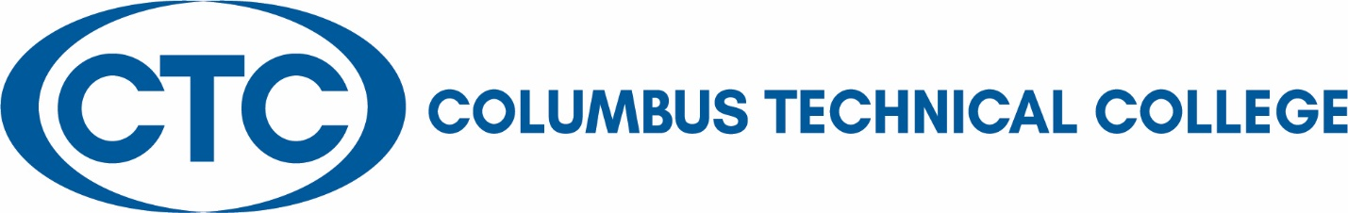
Privacy and Security of Student Data
The College complies with the Family Educational Rights and Privacy Act (FERPA) of 1974 and supports the right of students to inspect and review their educational records as published in the student handbook section of the College Catalog and Student Handbook. To ensure the confidentiality and integrity of its student records, no student’s educational records are released to anyone, except certain organizations stipulated by FERPA regulations, without the written consent of the student (FERPA Authorization Form and Transcript Release Form). In addition, under terms of the Act, the College classifies certain items of students’ records as directory information. These items may be released to any third party at the discretion of Columbus Technical College. Any student who objects to the release of directory information may file a Student Request to Restrict Directory Information Form with the Office of the Registrar.
To further protect the confidentiality of the student records, all new employees including Federal Work Study students who must access electronic and printed student records in the performance of their duties are required to complete FERPA training before access is granted. Training is provided during new-employee orientation. In addition, all faculty and staff members receive training regarding educational records and FERPA annually.
The Office of the Registrar is responsible for the integrity of student educational records, including those that are stored in the student database and other electronic formats and also in hard copy. Student educational records from 1994 to the present are kept on the College computer system. Records prior to 1994 are kept on microfilm. All permanent student records, including student applications, are kept in a secure vault that is accessible only to select staff in the Records and Admissions Offices. The vault is fireproof.
Columbus Technical College’s student records are maintained in the College’s student database system, Banner. The Information Technology (IT) team and BANNER Database Administrator have established security guidelines that limit employee access to student records in the student database. Employee security levels are appropriate to the employee’s position and allow access only to information necessary to conduct the job duties for that position. Each supervisor is responsible for requesting and monitoring employee access to the student database.
As outlined in the BANNER Account Policy, both BANNER and BANNER Web are protected access systems with multiple layers of protection. The first layer is a unique username and password/pin for access. This ensures that only the intended person is accessing the intended record each time. Strict password requirements and passwords are forcibly changed every 90 days to ensure the security standards are being upheld. In addition, the Banner database is backed up nightly to tape. The tapes are rotated on a daily basis and maintained onsite in a fireproof safe. A second copy of the database is also backed up to Technical College System of Georgia Data Center in Atlanta on a weekly schedule.

