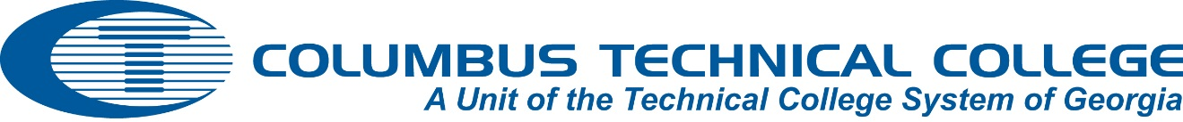

CTC Procedure: Faculty Participation in Curriculum Review

The responsibility for the content, quality, and effectiveness of curriculum rests with the faculty and administration at Columbus Technical College (CTC). Faculty are expected to be involved in the development and revision of program curriculum through participation in Instructional Faculty Consortium Committees (IFCC). The IFCC guidelines state that IFCC groups meet semiannually, if required, to ensure all program curricula are current with business and industry standards.

Faculty participate in Advisory Committees, Academic Council, and in development and evaluation of student learning and program outcomes. All program faculty are required to conduct two advisory committee meetings annually, one of which must contain a curriculum review. The knowledge of advisory committee members is used by Faculty to improve program operations and curriculum content. They analyze the curriculum recommendations and proposing institutional changes to Academic Council and reporting recommendations to the I FCC.

Academic Council is composed of faculty representatives from each area of the college and other faculty has the opportunity to propose institutional curriculum improvements to the Council for discussion. These curriculum changes include, but are not limited to course competencies, required assessment scores for programs or courses, prerequisite courses, Technical Certificate of Credit consolidations, and program elective courses. Annually, every faculty member participates in the development and evaluation of student learning outcomes and program outcomes.

Approved: LBoD: 2-14
Responsible: Vice President Academic Affairs
Review Date: 2016

