Important Information:
NEW Student Portal and Email
Effective December 10, 2018, the students of Columbus Technical College (CTC) will have a new email host. We will be moving from Gmail to Office 365. After December 10, 2018, you will no longer receive any emails in your CTC Gmail Inbox. Anyone who was a student prior to Spring semester of 2019 will still have access to their old Gmail archive account until June 2019 via the link provided in our portal. See the steps below to setup and access your new email.

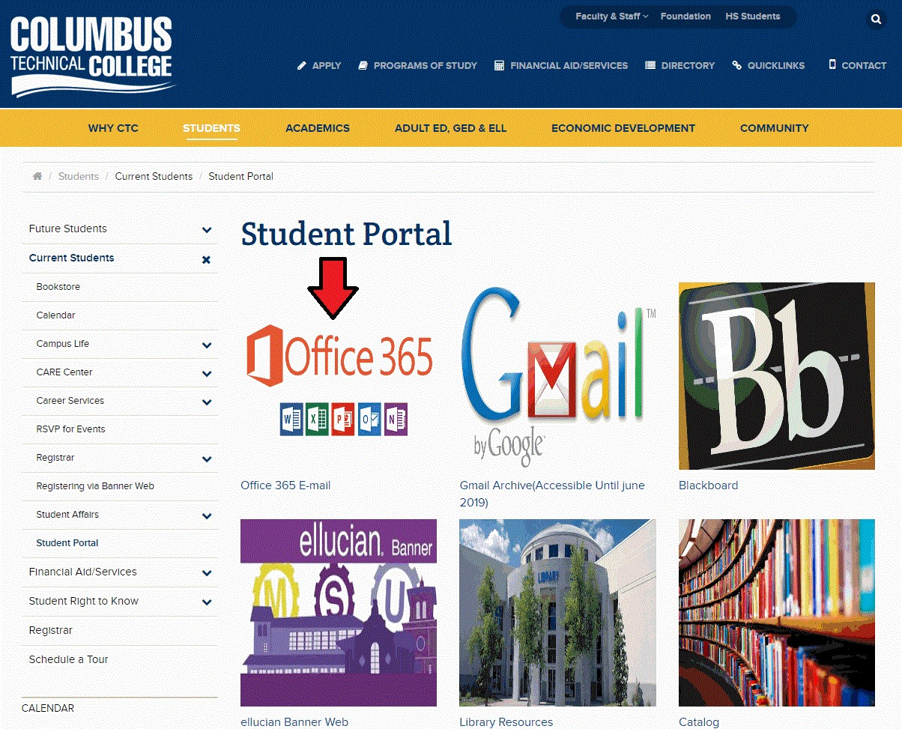
Go to www.columbustech.edu and point to Students (on the gold horizontal bar) -> click Current Students -> click Student Portal. For Office 365 email, click the link/picture below the red arrow.
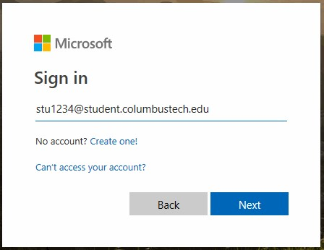
Log in using your CTC email address, which is your initials (first, middle, and last) followed by the last four digits of your nine-digit Student ID. Example, stu1234. This will be followed by @student.columbustech.edu. Note: If this does not work try it without the middle initial (su1234).

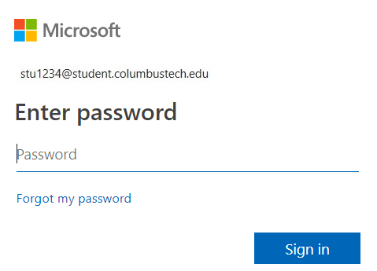
The password by default is your six-digit date of birth, in the format MMDDYY. Use the last two digits for birth year. Example, stu1234’s DOB is April 15, 1995 and his password would be 041595.
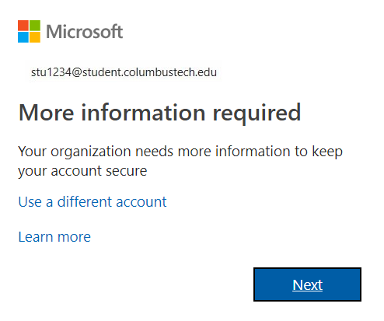
This screen means you have successfully logged in, but you must give more information for password recovery. This is NOT an error screen, and you MUST click Next to proceed.

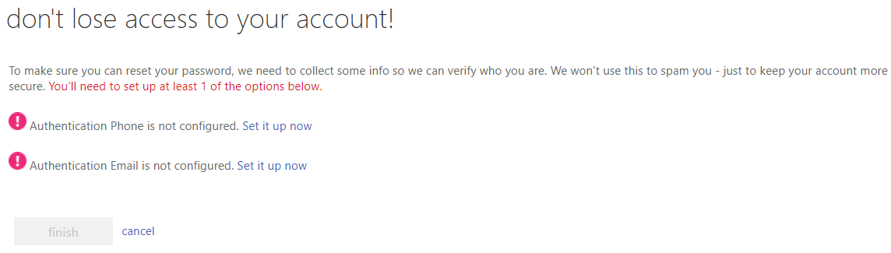

You must choose between providing a valid cell phone number, and/or a valid personal email address. A code will be sent to whichever option you choose, then you must enter the code. Only one option is needed. Once you have entered the code click the finish button.

Please read this paragraph carefully.
It will appear that the “More information is required” screen (see 1st image, page 3) is repeating, to proceed click the Next button. The “don’t lose access to your account!” screen (see 2nd image, page 3) will also reappear but now the finish button’s caption changes to looks good. Click the looks good button to display the screen below.
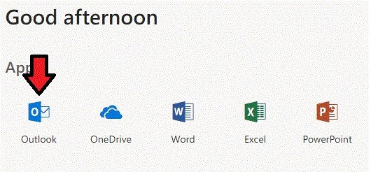
Access email inbox by clicking the Outlook icon (below red arrow). You will need to change the Time Zone to Eastern Time and click the Save button.
Note: You can also install the offline Office 365 Education suite from this screen. Please uninstall any old versions of Office you have before installing Office 365, then restart your computer.

Note: If you are a new student disregard the instructions below.
Gmail Archive Email

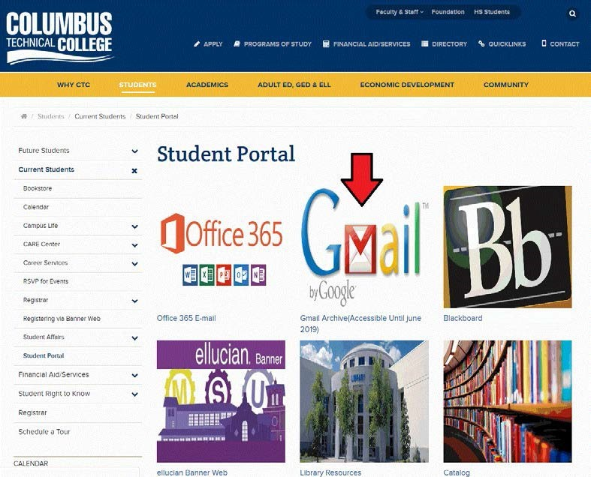

Note: The following instructions are for students who attended CTC before Spring semester 2019.

To access your Gmail archive, click the link/picture (below red arrow) on the Student Portal. Once login the only link you will see is the old student portal page login and the only active link will be your Gmail archive. (Gmail Archive will be available until June 2019)

If you are in need of any further assistance, please visit the Click computer lab located in Patrick Hall room 132.

Also any alumni not registered as a current student at CTC will no longer receive email to the old Gmail email inbox.

