New Student Password Standards
The security of your data is important to us. To ensure the security of your student account, password requirements are changing.

Beginning Spring Semester (January 2020), all students will be required to change their passwords to meet the new requirements.

8 Character Minimum and must include 3 of the 4 following items:
  - Upper case: A-Z
  - Lower case: a-z
  - Numbers: 0-9
  - Special chars: ~!@#$%^&*()_+=-{}[]`|?><,.;

New student accounts will use your initials, a hyphen, and date of birth as the initial password. For example, John H Smith, born 01/02/1970, student ID# 913456789 would use jhs6789 for his username and jhs-010270 as his initial password. The initial password must be changed at the first logon.

All students are encouraged to enroll in the self-service password reset feature in Office 365. This will allow you to reset your own password using your cell phone or personal email address.

Also along with the new password requirements we will be enabling another layer of security known as multi factor authentication below are the details and instructions for this process as well.
Multi Factor Authentication
To better secure your email accounts here at the College we are enabling stronger security measures the first of which is multi factor authentication to access O365 email. Once enabled on your account you will be forced to use one of three available methods to confirm your identity before accessing your web mail account. Below are screen shots showing this process.

Please note that the following screens will not be available until January 2020. Do not attempt to complete this process prior to January.

Go to https://portal.office.com
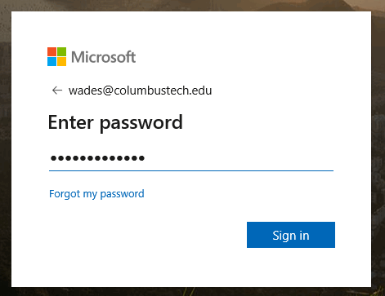

Once you enter your email and password you will be prompted for the following.
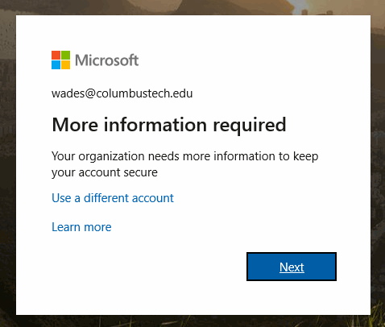
Choose the method to receive the code from Microsoft to verify your identity.
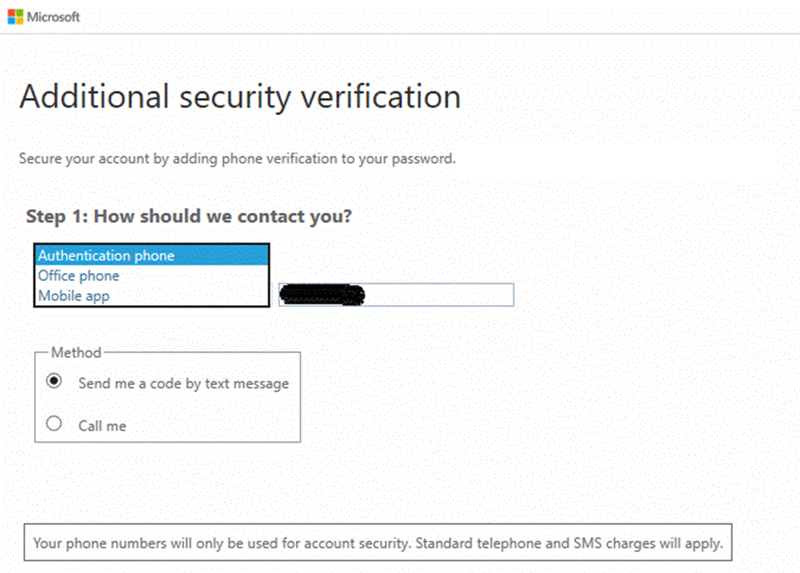

Once you choose and receive this code enter it here.
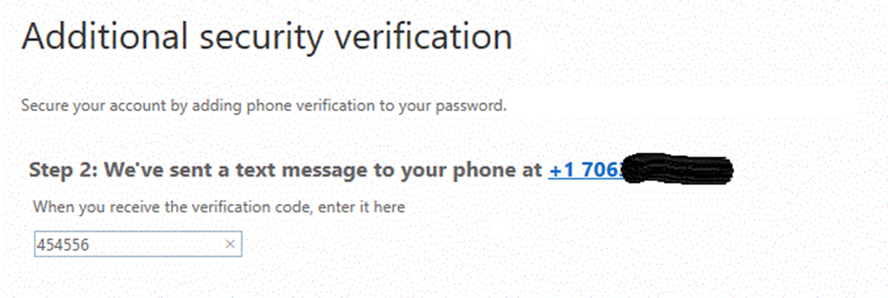
If you need assistance with this process, please visit the CLICK Lab located in P-132 or call 706-641-5020.

