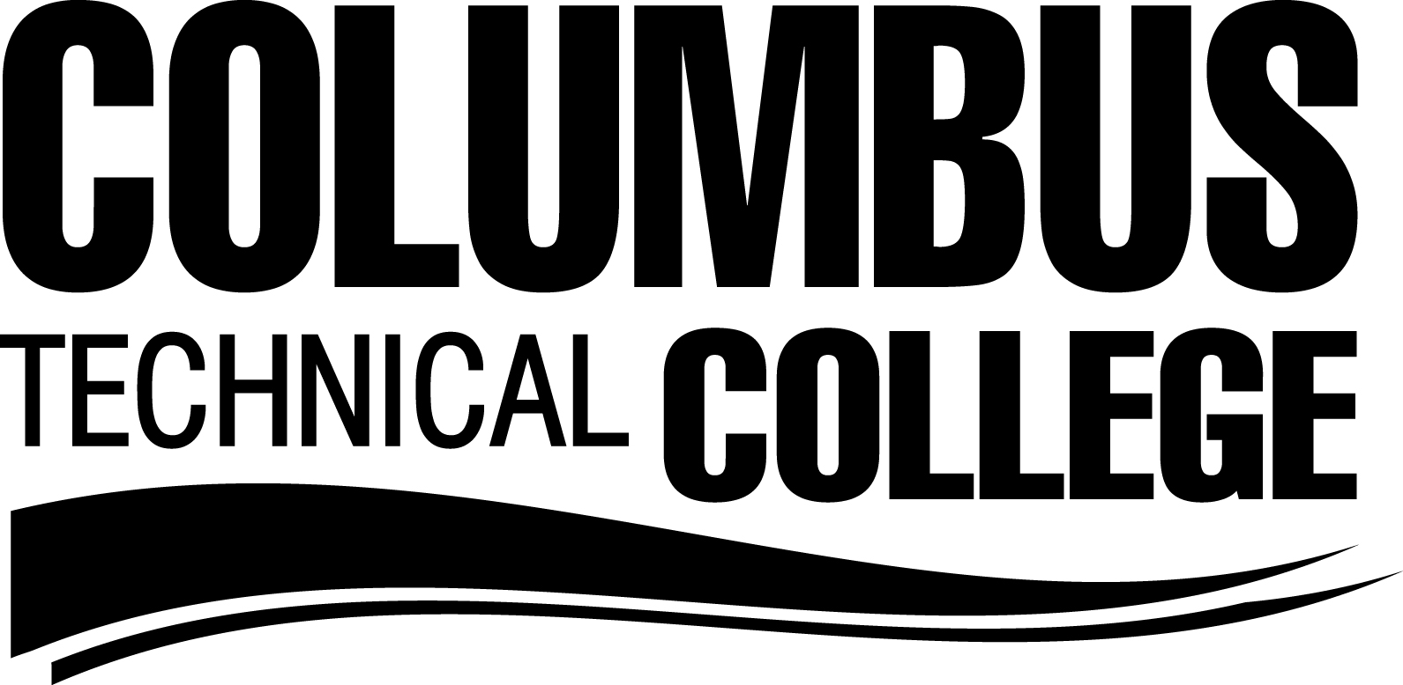
Letter of Intent Form
To be considered for admission into your program of choice, all sections of this form must be completed and returned to the Program Director on or before the deadline date designated by each program. Turn forms in to room 3325 of the Health Science Center

PLEASE PRINT
A. Personal Data:
Name: _______________________________________ _____________________ ___________________
Last First Middle College ID #
Address: __________________________________________________________________ __________
Street City State Zip
Phone: (Home) ______________________ (Work) _____________________

- Program of Intended Admission: (Circle One)

Degree: Dental Hygiene Diploma:
Nursing (Associate Degree)
LPN to RN Bridge (Associate Degree) Dental Assisting
Surgical Technology Medical Assisting
Radiologic Technology Pharmacy Technology
Diagnostic Medical Sonography Practical Nursing
Pharmacy Technology
Respiratory Care Technology
C. Semester of Intended Admission: (Circle One)
Spring Summer Fall Year: _____________

D. Accuplacer Scores:

Reading _____ Sentence Skills _____ Arithmetic_____ Elem. Alg _____ College level math _______
or
Compass Scores:
Reading ______ Writing _____ Pre-algebra _____ Algebra _______
E. Courses Completed or Transferred Credit From Another College
________________________ ______________________
________________________ ______________________
________________________ ______________________

F. Current GPA at Columbus Technical College: _________________

I certify that the information given above is correct and I wish to be considered for admission.

_________________________________________ ____________________
Student Signature Date

Program Use Only
Total Program Score ____
Grades Verified _________
GPA Verified __________ □ ACCEPTED □ NOT ACCEPTED
Accuplacer/Compass Verified ___________

