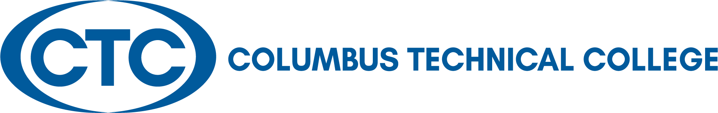

LOCAL BOARD OF DIRECTORS MEETING
September 28, 2021
12:30 p.m. J. Robert Jones Conference Technology Center

A G E N D A

Welcome and Call to Order Travis Chambers

Approval of Minutes for August 24, 2021 Travis Chambers

President’s Update Martha Ann Todd

Departments’ Reports/Presentation President’s Leadership Team

Academic Affairs – Kermelle Hensley
Administrative Services – Karen Thomas
Adult Education – April Hopson
Communications – Tara Askew
Economic Development – Jamie Loyd
Institutional Advancement – Susan Sealy
Institutional Effectiveness – Kermelle Hensley
Operations – Tommy Wilson
Student Affairs – Tara Askew

Adjourn Travis Chambers

Columbus Technical College
Local Board of Directors Meeting Minutes
928 Manchester Expressway
Columbus, GA 31904

Tuesday, August 24, 2021
12:30 p.m. - J. Robert Jones Conference Technology Center
Board of Directors:

Travis Chambers
Muscogee County

Senator Ed Harbison
Muscogee County

Martin Huff
Muscogee County

Isaiah Hugley
Muscogee County

Jon-Erik Jones
Quitman County

Pam Jordan
Talbot County

Judy King
Muscogee County

David Lewis
Muscogee County

Jerald Mitchell
Muscogee County

Sen. Randy Robertson
Harris County

Crystal Shahid
Muscogee County

Lisa J. Smith
Muscogee County

Rep. Vance Smith
Harris County

James “Jim” Trott
Harris County

Edwina G. Turner
Stewart County

Martha Ann Todd
President

Board Members Present: Travis Chambers, Chair, Ed Harbison, J. Martin Huff, Isaiah Hugley, Jon-Erik Jones, Pam Jordan, Judy King, David Lewis, Randy Robertson, Crystal Shahid, Vance Smith, Jim Trott, and Edwina Turner

Board Members Absent: Jerald Mitchell and Lisa Smith

Staff Present: Martha Ann Todd, Tara Askew, Kermelle Hensley, April Hopson, Jamie Loyd, Susan Sealy, and Karen Thomas

Call to Order: Chairman Travis Chambers called the August 24, 2021 meeting to order at 12:35 p.m.

Chairman Chambers first wanted to recognize three new board members who were not present at the last meeting to introduce themselves. They introduced themselves as following: Ms. Crystal Shahid with Synovus, Mr. David Lewis, Superintendent of the MCSD, and Mr. J. Martin Huff with The Cotton Company in Columbus. Chairman Chambers also asked the other board members and staffs to introduce themselves as well to the three new board members.

Approval of the Minutes of Last Meeting: Chairman Chambers called for any corrections to the minutes as written. After hearing none, he asked for a motion to approve the July 27, 2021 Minutes. A motion was made by Mr. Vance Smith to approve the minutes and seconded by Mr. Jim Trott. The minutes were approved.

Columbus Technical College Update – Martha Ann Todd

Ms. Todd thanked everyone for attending the meeting. She briefly outlined some information regarding the upcoming TCSG Leadership Conference scheduled for October 25-27. She encouraged the board members to complete their paperwork to register for the conference and submit it to Mary Alexander for processing. She also mentioned that training will be provided at the conference for Board certification. Training will also be made available in the fall on campus for board members to take advantage of to complete their certification as well. She reminded the board members to please ask questions at any time during the meeting and provide any feedback, suggestions, ideas, etc. She also gave an update on the following:

- Enrollment
  - Up 1.3% Summer 2021
  - Up almost 11% for Fall 2021
- A Culinary Facility on Campus
  - Plans for existing space in Patrick Hall
  - Construction begins early 2022
  - Anticipated occupancy date January 2023
- FY23 Large Capital Outlay
  - Renovation and new construction at 4848 River Road

Columbus Technical College
Local Board of Directors’ Meeting Minutes
August 24, 2021
Page 2

President Leadership Team’s (PLT) Department Reports
(See attached slide presentation below)

- Academic Affairs – Kermelle Hensley
- Administrative Services – Karen Thomas
- Adult Education – April Hopson
- Economic Development – Jamie Loyd
- Institutional Advancement – Susan Sealy
- Institutional Effectiveness – Kermelle Hensley
- Student Affairs (Enrollment/Communications) – Tara Askew
- Campus Operations – Tommy Wilson

Old Business – None

New Business – None

Adjourn: There were no other business for discussion. Upon appropriate motion and second, the Board adjourned at 1:40 p.m. The date of the next Board meeting is scheduled for September 28, 2021.

Minutes respectfully submitted by Ms. Mary Alexander, President’s Office

