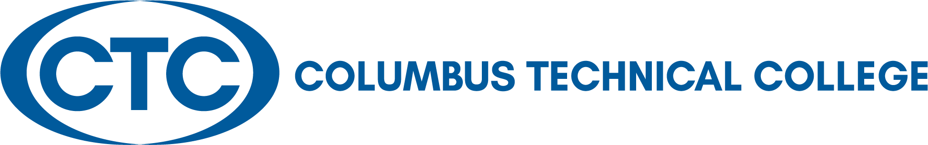

LOCAL BOARD OF DIRECTORS MEETING
March 22, 2022
12:30 p.m. J. Robert Jones Conference Technology Center

A G E N D A

Welcome and Call to Order Travis Chambers

Approval of Minutes for February 22, 2022 Travis Chambers

Columbus Technical College Update Martha Ann Todd

Departments’ Reports via Presentation President’s Leadership Team

Academic Affairs – Kermelle Hensley
Administrative Services – Karen Thomas
Adult Education – April Hopson
Communications – Tara Askew
Economic Development – Jamie Loyd
Institutional Advancement – Susan Sealy
Institutional Effectiveness – Kermelle Hensley
Operations – Tommy Wilson
Student Affairs – Tara Askew

Adjourn Travis Chambers

Columbus Technical College
Local Board of Directors Meeting Minutes
928 Manchester Expressway
Columbus, GA 31904

Tuesday, February 22, 2022
12:30 p.m. - J. Robert Jones Conference Technology Center
Board of Directors

Laura Lee Bernstein
Chattahoochee

Travis Chambers
Muscogee County

Senator Ed Harbison
Muscogee County

Martin Huff
Muscogee County

Isaiah Hugley
Muscogee County

Jon-Erik Jones
Quitman County

Pam Jordan
Talbot County

Judy King
Muscogee County

David Lewis
Muscogee County

Jerald Mitchell
Muscogee County

Sen. Randy Robertson
Harris County

Crystal Shahid
Muscogee County

Rep. Vance Smith
Harris County

James “Jim” Trott
Harris County

Edwina G. Turner
Stewart County

Martha Ann Todd
President

Board Members Present: Travis Chambers, Chair, Laura Lee Bernstein, Isaiah Hugley, Jon-Erik Jones, David Lewis, Pam Jordan, Judy King, Jerald Mitchell, Crystal Shahid, and Jim Trott,

Board Members Absent: Ed Harbison, J. Martin Huff, Randy Robertson, Vance Smith, and Edwina Turner

Staff Present: Tara Askew, April Hopson, Susan Sealy, Karen Thomas, Martha Ann Todd, and Tommy Wilson via WebEx.

Staff Absent: Jamie Loyd, Kermelle Hensley

Call to Order: Chairman Travis Chambers called the February 22, 2022 meeting to order at 12:35 p.m.

Approval of Minutes of Last Meeting: Chairman Chambers called for any corrections to the minutes as written. After hearing none, he asked for a motion to approve the January 25, 2022 Minutes. A motion was made by Mr. Isaiah Hugley to approve the minutes. Motion was seconded by Ms. Pam Jordan. Motion passed and the minutes were approved.

Columbus Technical College Update –Martha Ann Todd

Ms. Todd thanked everyone for attending the meeting. She made the following announcements:
- WebEx has been made available for the board members that are in the Legislative sessions should they decide to join the meeting.
- The Local Board will not meet in April due to the Leadership Team having to attend a TCSG event on April 25-28.
- All Board members will take pictures at the May 24th Local Board of Directors’ Meeting. Please come prepared to take a headshot photo. We will be set up in the area outside of the Technology Center as you come in to take your picture.
Ms. Todd also gave an update on the following:
- Enrollment update
- Campus tour is scheduled for March 10th for visitors from MCSD.
- CTC is the first technical college to go live with Target-X.
- CTC is in need of new hires for various positions.
- Partnership with Mercer Medical School
- Economic Development on Transport Blvd. is busy with on-going trainings.
- The Crime Prevent Grant Application will be submitted in March 2022.
- Currently working on a video with TCSG featuring CTC students and personnel.
- CTC programs at Fort Benning are now available.

Columbus Technical College
Local Board of Director’s Meeting Minutes
February 22, 2022
Page 2

- CTC Foundation, Inc. continues to work with new and current donors.
- CTC’s first responders’ employees will receive a $1,000 stipend approved by the Governor.
- Plans for the new Culinary Arts facility renovations is nearing the completion of Feb. 28th.
- Target date for the opening of the new Culinary Arts facility will be July 2023.
- The CDL project on going.
- The capital request for the Advance Manufacturing building did not make it into the Governor’s budget.

Presentation

Martha Ann introduced the following speakers who will represent the college at the 2022 TCSG Summit in April:

- Adult Education Teacher of the Year - Frances Edwards
- Rick Perkins Award for Excellence in Teaching - Natasha Snider
- Exceptional Adult Georgian in Literacy Education (EAGLE) - Angela Sevier
- Georgia Occupational Award of Leadership (GOAL) - Shelley Le

Old Business – None

New Business – None

Adjourn: There were no other business for discussion. Upon appropriate motion and second, the Board adjourned at 1:10 p.m. The date of the next Board meeting is scheduled for March 22, 2022.

Minutes respectfully submitted by Ms. Mary Alexander, President’s Office

